# C:\Users\Sanjida.Ks\Downloads\cover page.png

# PROJECT NAME: RESTAURANT MANAGEMENT SYSTEM

**Course Title:** Web and internet programming

**Course Code:** CSE4033.1

# Submitted to

**Md. Mijanur Rahman**

**Assistant Professor**

**Southeast University**

# Submitted by

**Name: Urme Akter Sheuli**

**ID : 2018100000017**

**Name: MD. Tarekahammed Raju**

**ID : 2018100000015**

**Name: Mahinur Akter**

**ID : 2018100000008**

# Date of Submission: 6th February, 2022

**HOME PAGE**

**rms.html**

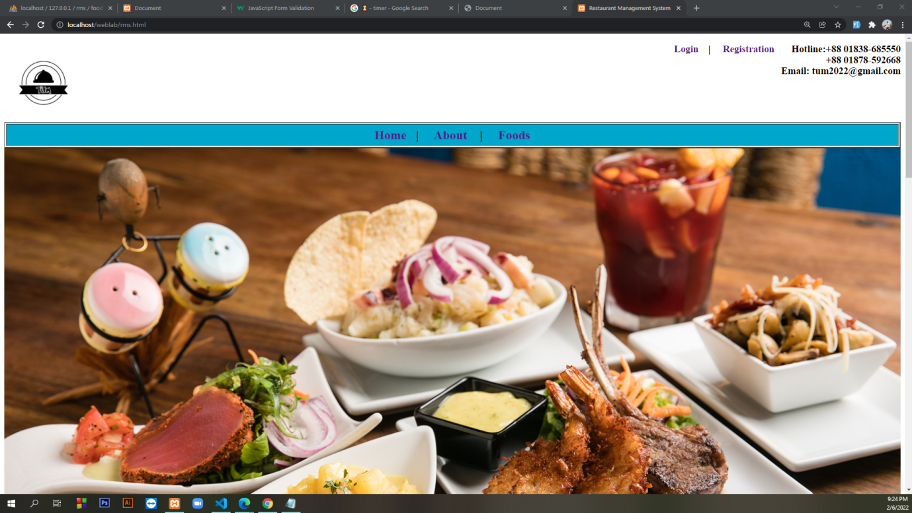

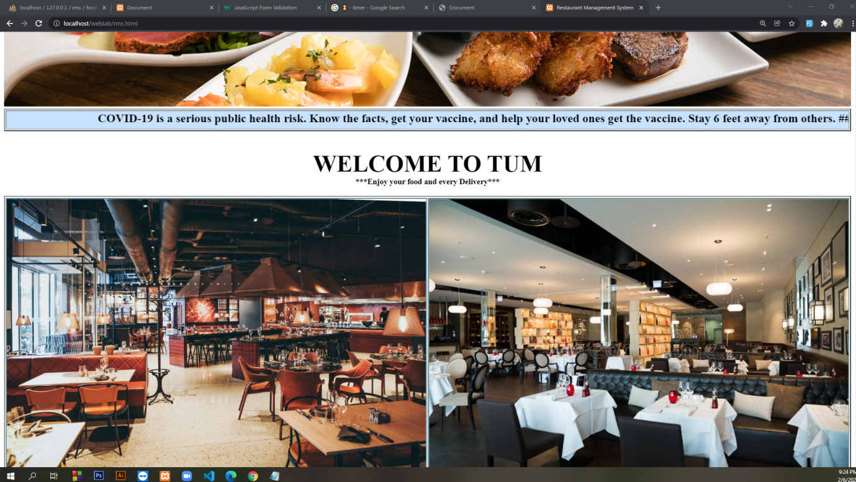

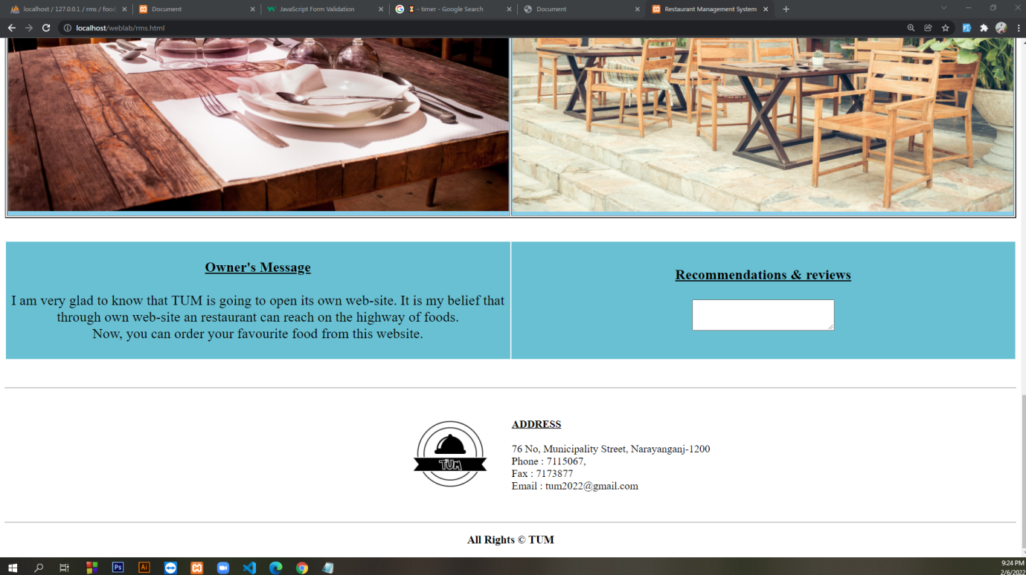

<!DOCTYPE html>

<html lang="en">

<head>

<meta charset="UTF-8">

<meta http-equiv="X-UA-Compatible" content="IE=edge">

<meta name="viewport" content="width=device-width, initial-scale=1.0">

<title>Restaurant Management System</title>

<link rel="stylesheet" href="style.css">

</head>

<body>

<a href="rms.html"><img align="left" height="150" width="150" src="logo.jpg"> </a>

<h3 align="right"><a class="abc" href="login.html">Login</a> &nbsp&nbsp&nbsp| &nbsp&nbsp&nbsp <a class="abc"

href="registration.html">Registration</a>

&nbsp&nbsp&nbsp&nbsp&nbsp&nbspHotline:+88 01838-685550 </br> +88 01878-592668 <br>

Email: tum2022@gmail.com </h3>

<table border="2" height="50" width="100%">

<tr height="100%" width="100%">

<td bgcolor=#00a6cb>

<center>

<font size="5">

<b>

<a class="abc" href="rms.html">Home</a>&nbsp&nbsp&nbsp| &nbsp&nbsp&nbsp

<a class="abc" href="about.html">About</a> &nbsp&nbsp&nbsp| &nbsp&nbsp&nbsp

<a class="abc" href="food.html">Foods</a>

</b>

</font>

</center>

</td>

</tr>

</table>

<center><img height="750" width="100%" src="SP_WEB_COVER-SLIDE4.jpg"></center>

<table border="2" height="6%" width="100%">

<tr height="100%" width="100%">

<td bgcolor=#c7e2fe>

<center>

<font size="5">

<marquee> <b> COVID-19 is a serious public health risk. Know the facts, get your vaccine,

and help your loved ones get the vaccine.

Stay 6 feet away from others. ##Inside your home: Avoid close contact with people

who are sick.

##Outside your home: Remember that some people without symptoms may spread the

virus. Stay at least 6 feet (about two arm lengths) from other people. </b>

</marquee>

</b>

</font>

</center>

</td>

</tr>

</table>

</br></br>

<center><b>

<font size="7"> WELCOME TO TUM</font>

</b>

</center>

<center><b>

<font size="3">

***Enjoy your food and every Delivery*** </font>

</b>

</center>

</br>

<table border="2" height="50%" width="100%">

<tr>

<td height="50%" width="50%" bgcolor="SkyBlue">

<center><img height="50%" width="100%" src="photo-1552566626-52f8b828add9.jpg"></center>

</td>

<td height="50%" width="50%" bgcolor="SkyBlue">

<center><img height="50%" width="100%"

src="red-white-brown-restaurant-interior-decoration-restaurant-interior-decoration-dressed-square-tables-white-cloth-120637295.jpg">

</center>

</td>

</tr>

<tr>

<td height="50%" width="50%" bgcolor="SkyBlue">

<center><img height="100%" width="100%" src="pexels-skitterphoto-9315.jpg"></center>

</td>

<td height="50%" width="50%" bgcolor="SkyBlue">

<center><img height="100%" width="100%" src="pexels-tirachard-kumtanom-601169.jpg"></center>

</td>

</tr>

</table> </br> </br>

<table border="0" height="auto" width="100%">

<tr>

<td height="20%" width="50%" bgcolor=#69c0d2>

<center>

<font size="5">

</br> <b><u>Owner's Message</u></b> </br> </br>

I am very glad to know that TUM is going to open its own web-site. It

is my belief that through own web-site an restaurant can reach on the highway

of foods. <br>

Now, you can order your favourite food from this website.</br></br>

</font>

</center>

</td>

<td height="20%" width="50%" bgcolor=#69c0d2>

<center>

<font size="5">

</br> <b><u> Recommendations & reviews</u></b> </br> </br>

<textarea rows="3" cols="30" name="way" > </textarea> </br></br>

</font>

</center>

</td>

</tr>

</table>

</br> </br>

<hr>

<table border="0" height="10%" width="100%">

<tr>

<td height="20%" width="50%" bgcolor="white">

<DIV align="right"><a href="rms.html"><img height="200" width="200" src="logo.jpg"></a></DIV>

</td>

<td height="20%" width="50%" bgcolor="white">

<font size="4">

<DIV align="left">

</br> <b><u> ADDRESS</u></b> </br> </br>

</DIV>

76 No, Municipality Street, Narayanganj-1200</br>

Phone : 7115067, </br>

Fax : 7173877</br>

Email : tum2022@gmail.com</br></br>

</font>

</align>

</center>

</td>

</tr>

</table>

<hr>

<h3 align="center">All Rights &copy; TUM </h3>

</body>

</html>

**LOGIN (USER)**

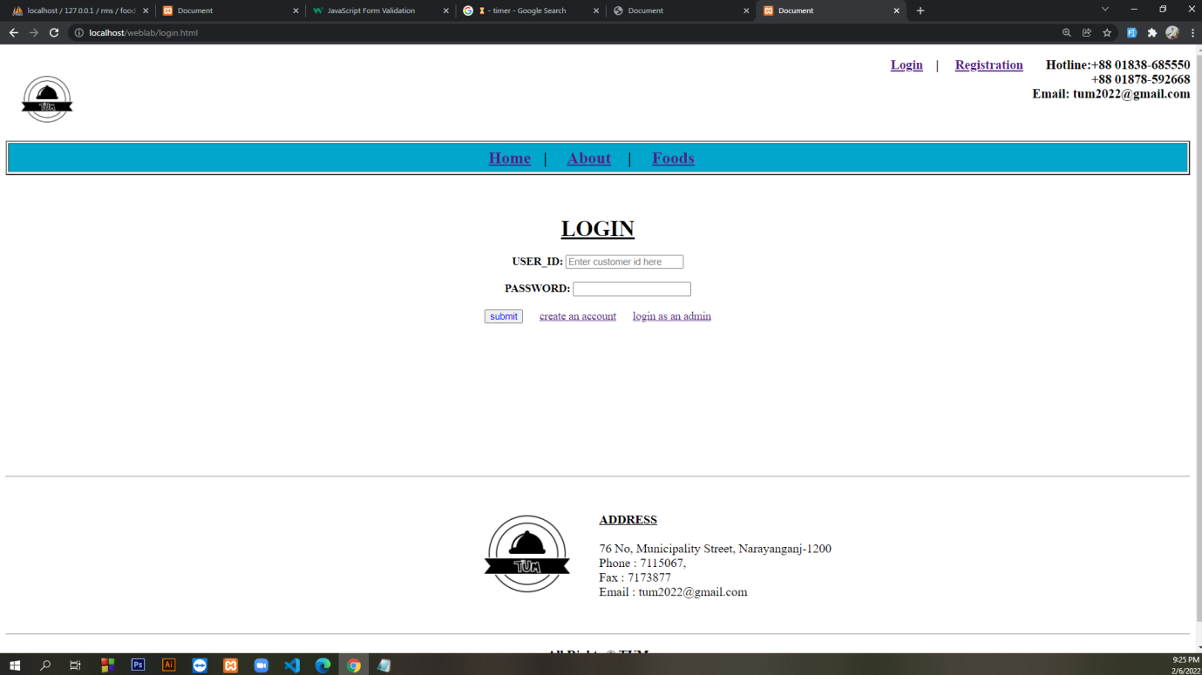

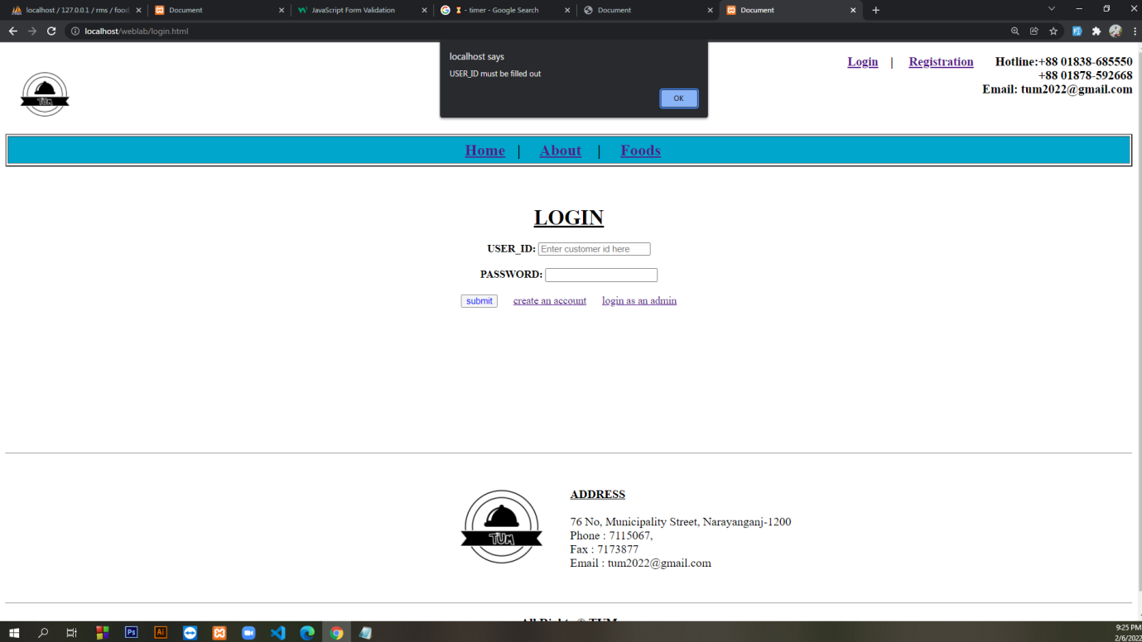

**login.html**

<!DOCTYPE html>

<html lang="en">

<head>

<meta charset="UTF-8">

<meta http-equiv="X-UA-Compatible" content="IE=edge">

<meta name="viewport" content="width=device-width, initial-scale=1.0">

<title>Document</title>

</head>

<body>

<a href="rms.html"><img align="left" height="120" width="120" src="logo.jpg"> </a>

<h3 align="right"><a href="login.html">Login</a> &nbsp&nbsp&nbsp| &nbsp&nbsp&nbsp <a

href="registration.html">Registration</a>

&nbsp&nbsp&nbsp&nbsp&nbsp&nbspHotline:+88 01838-685550 </br> +88 01878-592668 <br>

Email: tum2022@gmail.com </h3>

</br>

<table border="2" height="50" width="100%">

<tr height="100%" width="100%">

<td bgcolor=#00a6cb>

<center>

<font size="5">

<b>

<a href="rms.html">Home</a>&nbsp&nbsp&nbsp| &nbsp&nbsp&nbsp

<a href="about.html">About</a> &nbsp&nbsp&nbsp| &nbsp&nbsp&nbsp

<a href="food.html">Foods</a>&nbsp&nbsp&nbsp

</b>

</font>

</center>

</td>

</tr>

</table>

<table border="0" height="auto" width="100%">

<tr>

<td height="20%" width="50%" bgcolor="white">

<form name="myForm" form action="login.php" onsubmit="return validateForm()" method="post">

<center>

</br></br></br>

<font size="6"><u><b>LOGIN</b></u></font> </br></br>

<label><b>USER_ID:</b></label>

<input type="text" placeholder="Enter customer id here" name="uid"> </br></br>

<label><b>PASSWORD:</b></label>

<input type="password" name="password"> </br></br>

<input type="Submit" style="color:blue" value="submit" name="button">

&nbsp&nbsp&nbsp&nbsp

<a href="registration.html">create an account</a>

&nbsp&nbsp&nbsp&nbsp

<a href="admindata.html">login as an admin</a>

</br></br>

</form>

<script>

function validateForm() {

let x = document.forms["myForm"]["uid"].value;

if (x == "") {

alert("USER_ID must be filled out");

return false;

}

let y = document.forms["myForm"]["password"].value;

if (y == "") {

alert("PASSWORD must be filled out");

return false;

}

}

</script>

</td>

</tr>

</table>

</br></br></br></br></br></br></br></br></br></br>

<hr>

<table border="0" height="10%" width="100%">

<tr>

<td height="20%" width="50%" bgcolor="white">

<DIV align="right"><a href="rms.html"><img height="200" width="200" src="logo.jpg"></a></DIV>

</td>

<td height="20%" width="50%" bgcolor="white">

<font size="4">

<DIV align="left">

</br> <b><u> ADDRESS</u></b> </br> </br>

</DIV>

76 No, Municipality Street, Narayanganj-1200</br>

Phone : 7115067, </br>

Fax : 7173877</br>

Email : tum2022@gmail.com</br></br>

</font>

</align>

</center>

</td>

</tr>

</table>

<hr>

<h3 align="center">All Rights &copy; TUM </h3>

</body>

</html>

**login.php**

**(user will go to food order page after login)**

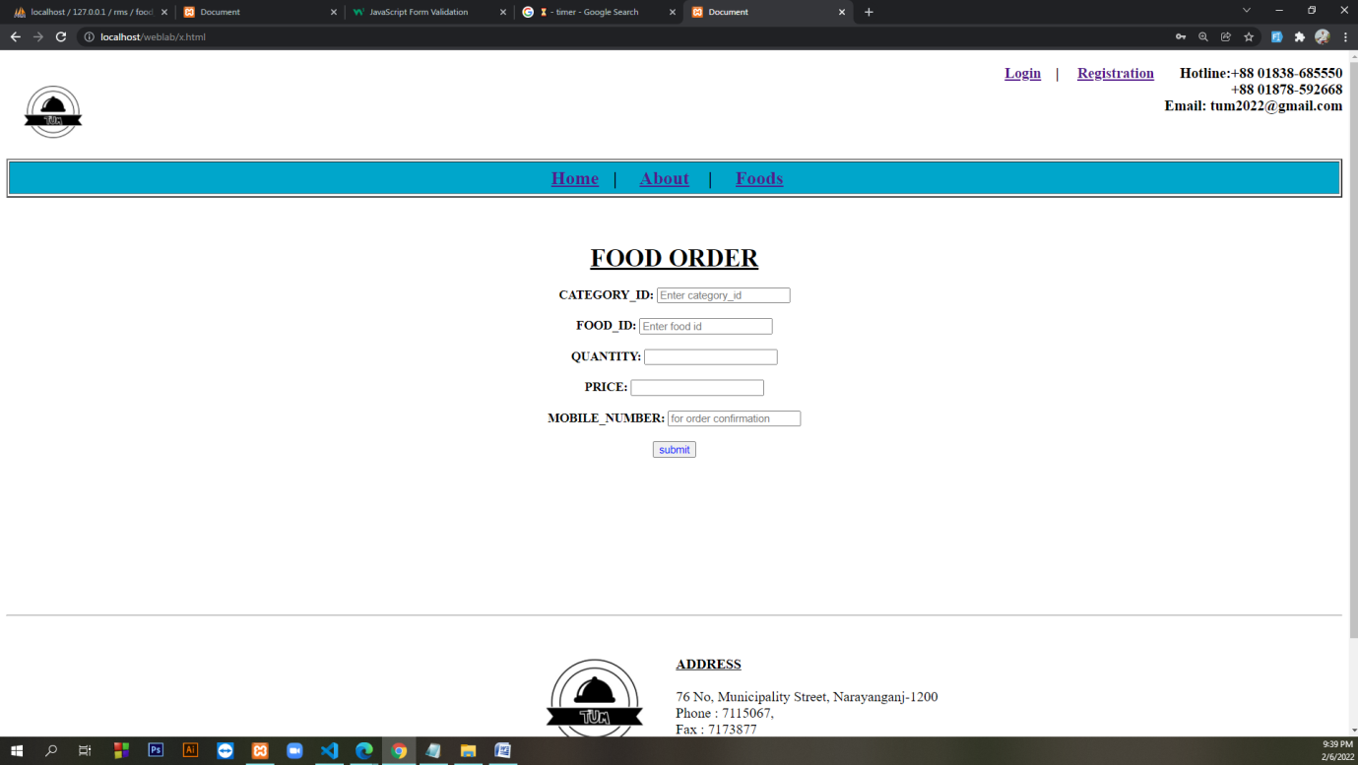

<?php

$con=mysqli_connect('localhost','root', '','rms');

if (isset ($_POST['button']))

{

$uid = $_POST ['uid'];

$pass = $_POST ['password'];

$sql = "SELECT * FROM REGISTRATION WHERE user_id = '$uid' and password = '$pass'";

$result = mysqli_query($con,$sql);

$cnt= mysqli_num_rows ($result);

if($cnt==1)

{

echo "Login Successful";

header('location: x.html');

}

else {

echo "Login Unsuccessful";

}

}

**registration.html**

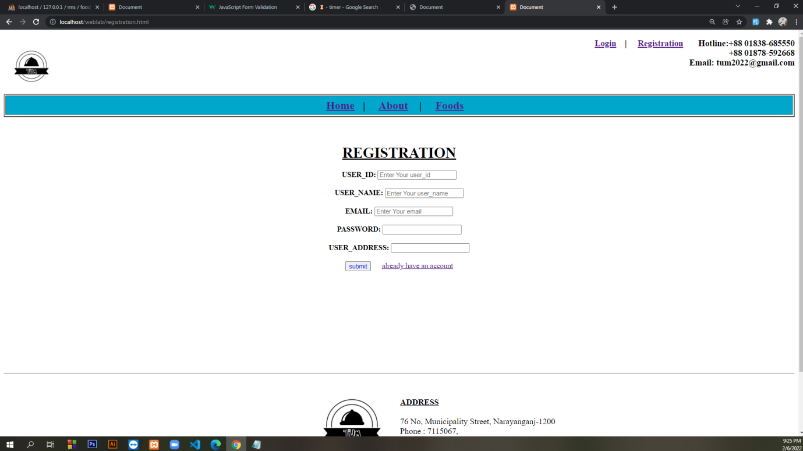

<!DOCTYPE html>

<html lang="en">

<head>

<meta charset="UTF-8">

<meta http-equiv="X-UA-Compatible" content="IE=edge">

<meta name="viewport" content="width=device-width, initial-scale=1.0">

<title>Document</title>

</head>

<body>

<a href="rms.html"><img align="left" height="120" width="120" src="logo.jpg"> </a>

<h3 align="right"><a href="login.html">Login</a> &nbsp&nbsp&nbsp| &nbsp&nbsp&nbsp <a

href="registration.html">Registration</a>

&nbsp&nbsp&nbsp&nbsp&nbsp&nbspHotline:+88 01838-685550 </br> +88 01878-592668 <br>

Email: tum2022@gmail.com </h3>

</br>

<table border="2" height="50" width="100%">

<tr height="100%" width="100%">

<td bgcolor=#00a6cb>

<center>

<font size="5">

<b>

<a href="rms.html">Home</a>&nbsp&nbsp&nbsp| &nbsp&nbsp&nbsp

<a href="about.html">About</a> &nbsp&nbsp&nbsp| &nbsp&nbsp&nbsp

<a href="food.html">Foods</a>&nbsp&nbsp&nbsp

</b>

</font>

</center>

</td>

</tr>

</table>

<table border="0" height="auto" width="100%">

<tr>

<td height="20%" width="50%" bgcolor="white">

<form name="myForm" form action="registration.php" onsubmit="return validateForm()" method="post">

<center>

</br></br></br>

<font size="6"><u><b>REGISTRATION</b></u></font> </br></br>

<label><b>USER_ID:</b></label>

<input type="text" placeholder="Enter Your user_id" name="uid"> </br></br>

<label><b>USER_NAME:</b></label>

<input type="text" placeholder="Enter Your user_name" name="name"> </br></br>

<label><b>EMAIL:</b></label>

<input type="email" placeholder="Enter Your email" name="email"> </br></br>

<label><b>PASSWORD:</b></label>

<input type="password" name="password"> </br></br>

<label><b>USER_ADDRESS:</b></label>

<input type="text" name="uadrs"> </br></br>

<input type="Submit" style="color:blue" value="submit" name="button">

&nbsp&nbsp&nbsp&nbsp

<a href="login.html">already have an account</a></br></br>

</form>

<script>

function validateForm() {

let a = document.forms["myForm"]["uid"].value;

if (a == "") {

alert("USER_ID must be filled out");

return false;

}

let b = document.forms["myForm"]["name"].value;

if (b == "") {

alert("Name must be filled out");

return false;

}

let c = document.forms["myForm"]["email"].value;

if (c == "") {

alert("Email must be filled out");

return false;

}

let d = document.forms["myForm"]["password"].value;

if (d == "") {

alert("PASSWORD must be filled out");

return false;

}

let e = document.forms["myForm"]["uadrs"].value;

if (e == "") {

alert("User_Address must be filled out");

return false;

}

}

</script>

</td>

</tr>

</table>

</br></br></br></br></br></br></br></br></br></br>

<hr>

<table border="0" height="10%" width="100%">

<tr>

<td height="20%" width="50%" bgcolor="white">

<DIV align="right"><a href="rms.html"><img height="200" width="200" src="logo.jpg"></a></DIV>

</td>

<td height="20%" width="50%" bgcolor="white">

<font size="4">

<DIV align="left">

</br> <b><u> ADDRESS</u></b> </br> </br>

</DIV>

76 No, Municipality Street, Narayanganj-1200</br>

Phone : 7115067, </br>

Fax : 7173877</br>

Email : tum2022@gmail.com</br></br>

</font>

</align>

</center>

</td>

</tr>

</table>

<hr>

<h3 align="center">All Rights &copy; TUM </h3>

</body>

</html>

**registration.php**

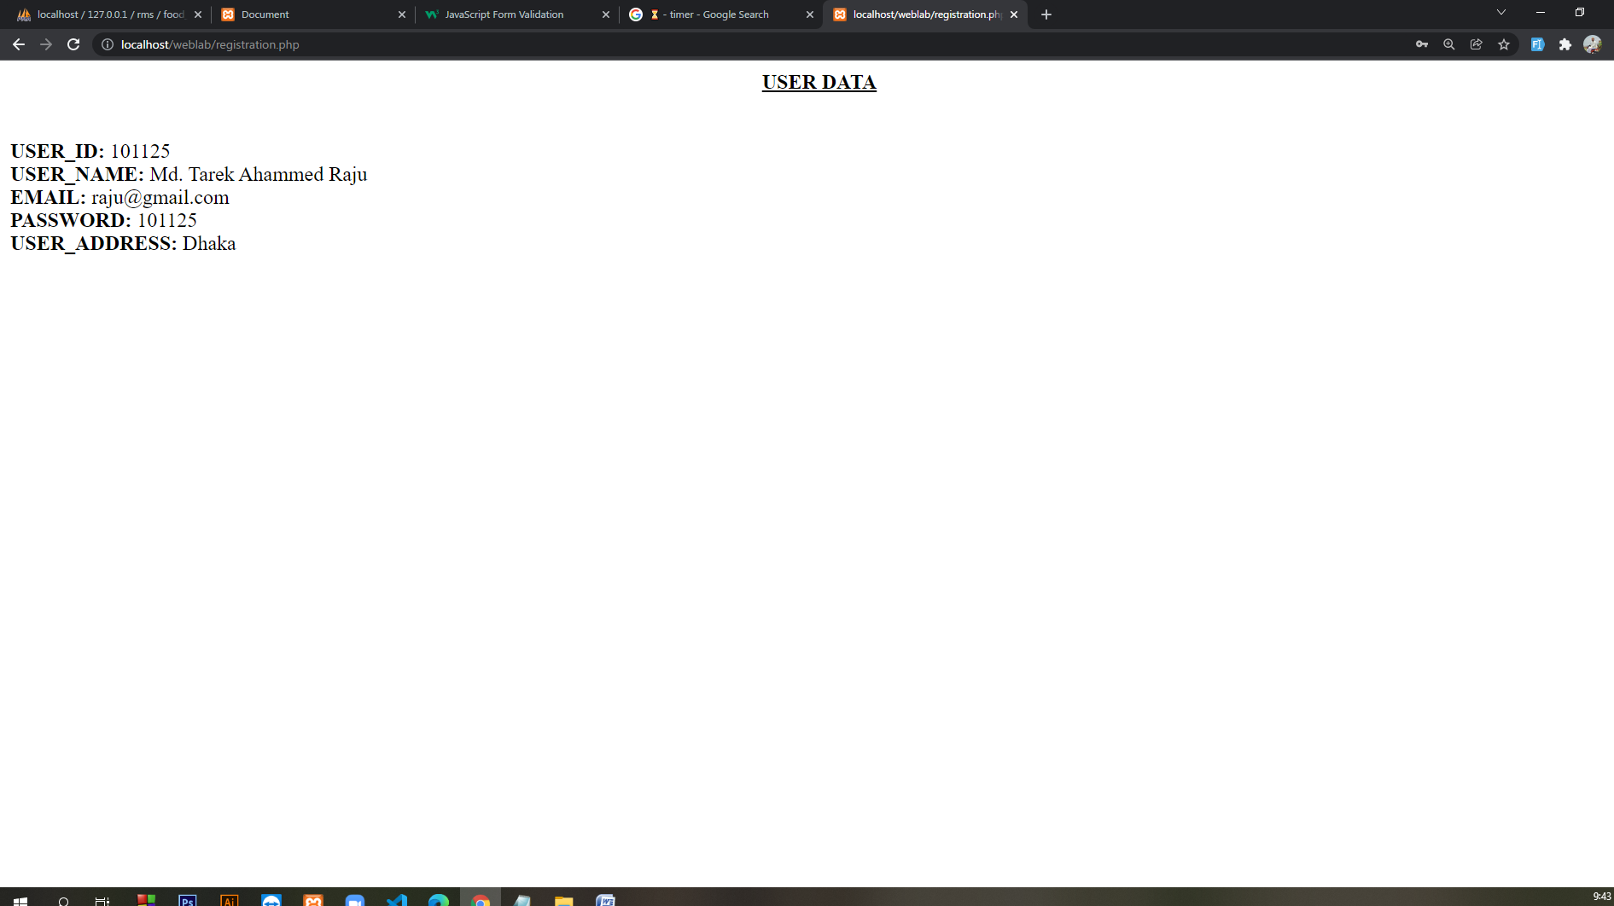

<?php

$con=mysqli_connect('localhost','root', '','rms');

if (isset ($_POST['button']))

{

$uid = $_POST ['uid'];

$uname = $_POST ['name'];

$email = $_POST ['email'];

$pass = $_POST ['password'];

$uadrs = $_POST ['uadrs'];

}

echo "<center><b><u> USER DATA</u> </b></center>";

echo "</br>";

echo "</br>";

echo "<b>USER_ID:</b> $uid";

echo "</br>";

echo "<b>USER_NAME:</b> $uname";

echo "</br>";

echo "<b>EMAIL:</b> $email";

echo "</br>";

echo "<b>PASSWORD:</b> $pass";

echo "</br>";

echo "<b>USER_ADDRESS:</b> $uadrs";

echo "</br>";

$sql="insert into registration (user_id,user_name,email,password,user_address)values('$uid','$uname','$email','$pass','$uadrs')";

mysqli_query($con,$sql);

?>

**admindata.html**

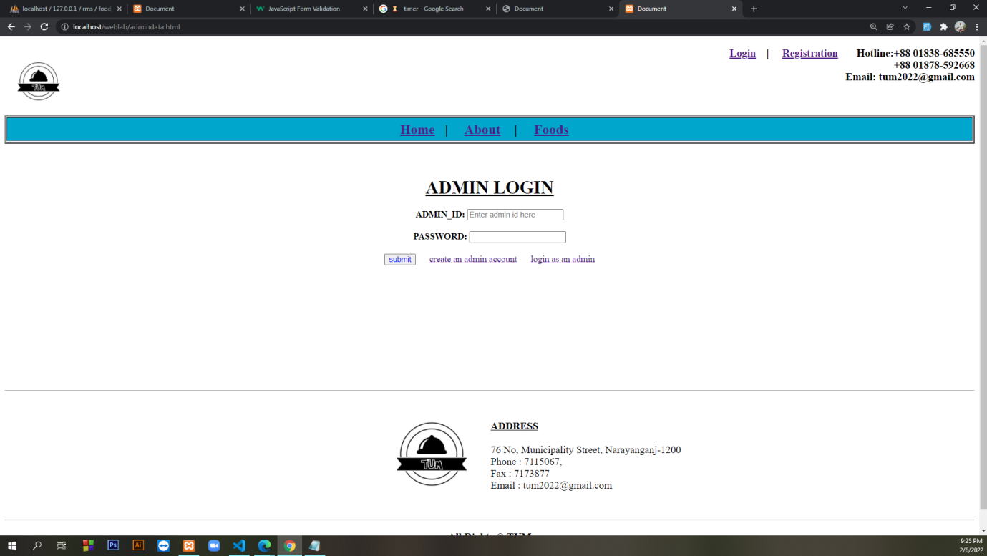

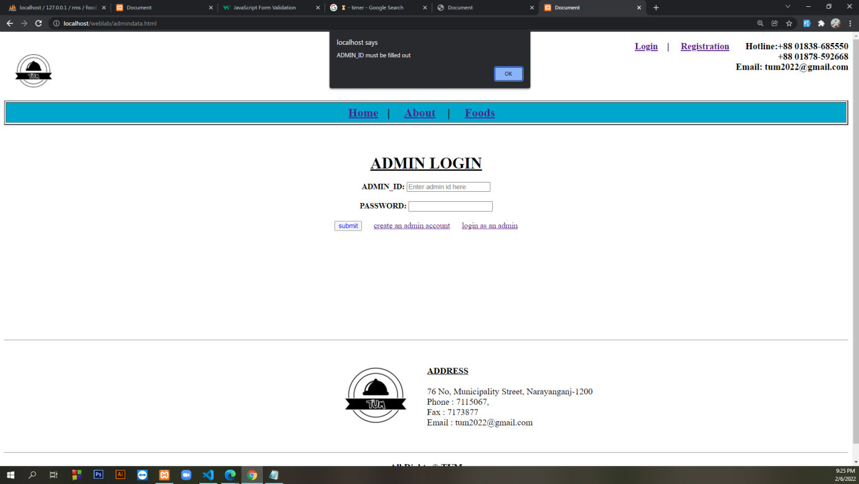

<!DOCTYPE html>

<html lang="en">

<head>

<meta charset="UTF-8">

<meta http-equiv="X-UA-Compatible" content="IE=edge">

<meta name="viewport" content="width=device-width, initial-scale=1.0">

<title>Document</title>

</head>

<body>

<a href="rms.html"><img align="left" height="120" width="120" src="logo.jpg"> </a>

<h3 align="right"><a href="login.html">Login</a> &nbsp&nbsp&nbsp| &nbsp&nbsp&nbsp <a

href="registration.html">Registration</a>

&nbsp&nbsp&nbsp&nbsp&nbsp&nbspHotline:+88 01838-685550 </br> +88 01878-592668 <br>

Email: tum2022@gmail.com </h3>

</br>

<table border="2" height="50" width="100%">

<tr height="100%" width="100%">

<td bgcolor=#00a6cb>

<center>

<font size="5">

<b>

<a href="rms.html">Home</a>&nbsp&nbsp&nbsp| &nbsp&nbsp&nbsp

<a href="about.html">About</a> &nbsp&nbsp&nbsp| &nbsp&nbsp&nbsp

<a href="food.html">Foods</a>&nbsp&nbsp&nbsp

</b>

</font>

</center>

</td>

</tr>

</table>

<table border="0" height="auto" width="100%">

<tr>

<td height="20%" width="50%" bgcolor="white">

<form name="myForm" form action="admindata.php" onsubmit="return validateForm()" method="post">

<center>

</br></br></br>

<font size="6"><u><b>ADMIN LOGIN</b></u></font> </br></br>

<label><b>ADMIN_ID:</b></label>

<input type="text" placeholder="Enter admin id here" name="aid"> </br></br>

<label><b>PASSWORD:</b></label>

<input type="password" name="adpass"> </br></br>

<input type="Submit" style="color:blue" value="submit" name="button">

&nbsp&nbsp&nbsp&nbsp

<a href="adminregistration.html">create an admin account</a>

&nbsp&nbsp&nbsp&nbsp

<a href="admindata.html">login as an admin</a>

</br></br>

</form>

<script>

function validateForm() {

let x = document.forms["myForm"]["aid"].value;

if (x == "") {

alert("ADMIN_ID must be filled out");

return false;

}

let y = document.forms["myForm"]["adpass"].value;

if (y == "") {

alert("PASSWORD must be filled out");

return false;

}

}

</script>

</td>

</tr>

</table>

</br></br></br></br></br></br></br></br></br></br>

<hr>

<table border="0" height="10%" width="100%">

<tr>

<td height="20%" width="50%" bgcolor="white">

<DIV align="right"><a href="rms.html"><img height="200" width="200" src="logo.jpg"></a></DIV>

</td>

<td height="20%" width="50%" bgcolor="white">

<font size="4">

<DIV align="left">

</br> <b><u> ADDRESS</u></b> </br> </br>

</DIV>

76 No, Municipality Street, Narayanganj-1200</br>

Phone : 7115067, </br>

Fax : 7173877</br>

Email : tum2022@gmail.com</br></br>

</font>

</align>

</center>

</td>

</tr>

</table>

<hr>

<h3 align="center">All Rights &copy; TUM </h3>

</body>

</html>

**adminregistration.html**

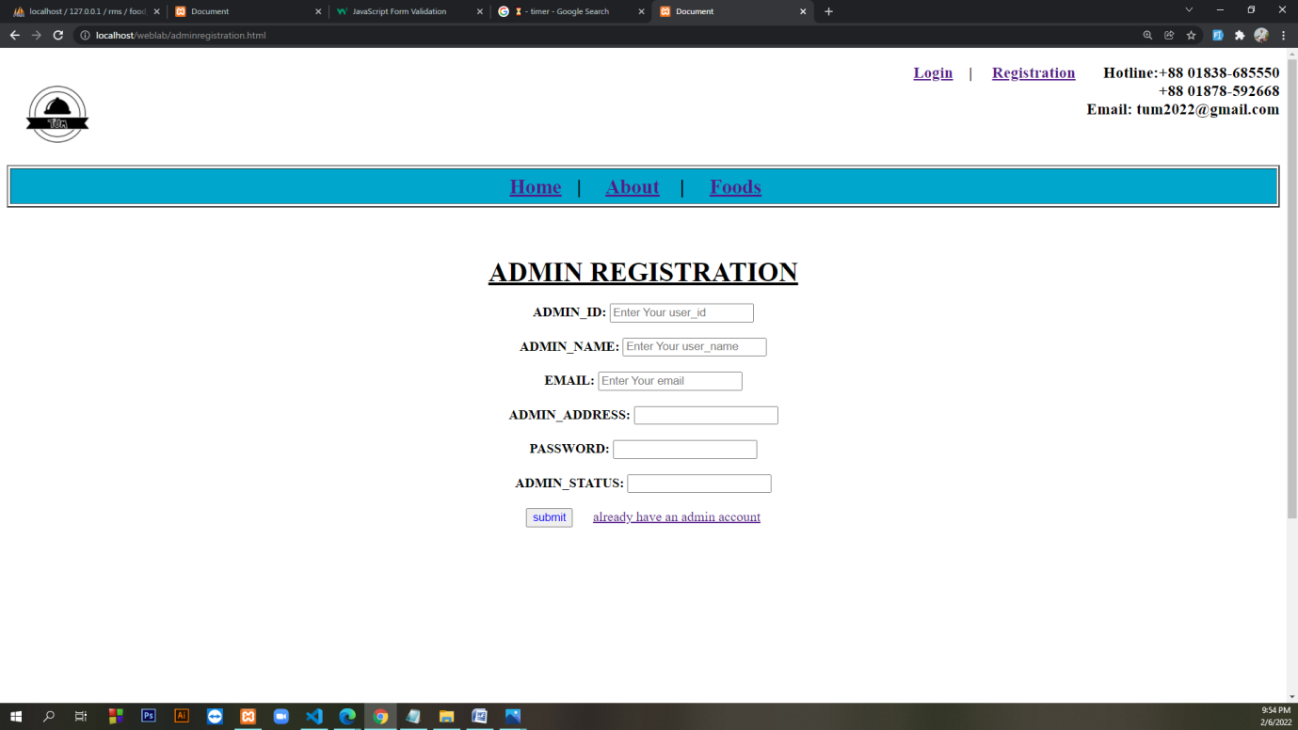

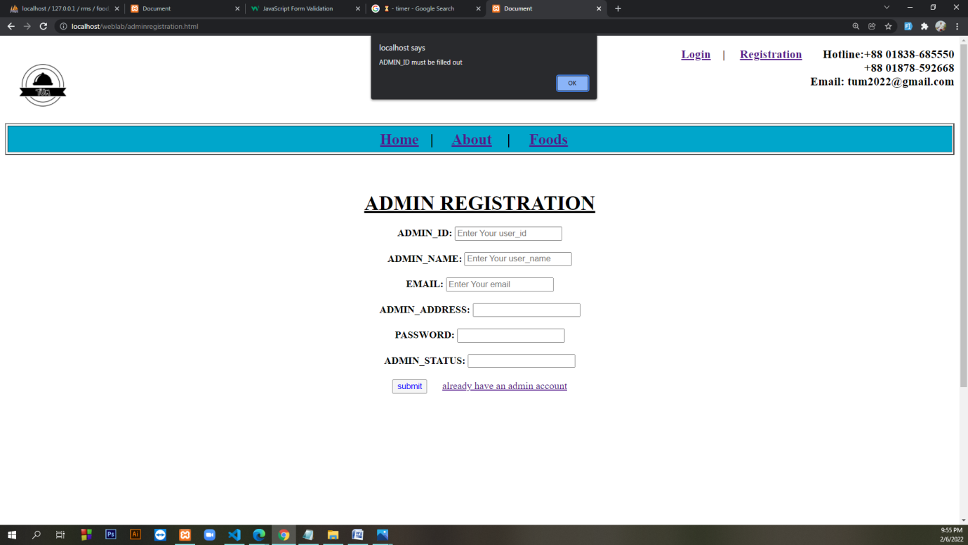

<!DOCTYPE html>

<html lang="en">

<head>

<meta charset="UTF-8">

<meta http-equiv="X-UA-Compatible" content="IE=edge">

<meta name="viewport" content="width=device-width, initial-scale=1.0">

<title>Document</title>

</head>

<body>

<a href="rms.html"><img align="left" height="120" width="120" src="logo.jpg"> </a>

<h3 align="right"><a href="login.html">Login</a> &nbsp&nbsp&nbsp| &nbsp&nbsp&nbsp <a

href="registration.html">Registration</a>

&nbsp&nbsp&nbsp&nbsp&nbsp&nbspHotline:+88 01838-685550 </br> +88 01878-592668 <br>

Email: tum2022@gmail.com </h3>

</br>

<table border="2" height="50" width="100%">

<tr height="100%" width="100%">

<td bgcolor=#00a6cb>

<center>

<font size="5">

<b>

<a href="rms.html">Home</a>&nbsp&nbsp&nbsp| &nbsp&nbsp&nbsp

<a href="about.html">About</a> &nbsp&nbsp&nbsp| &nbsp&nbsp&nbsp

<a href="food.html">Foods</a>&nbsp&nbsp&nbsp

</b>

</font>

</center>

</td>

</tr>

</table>

<table border="0" height="auto" width="100%">

<tr>

<td height="20%" width="50%" bgcolor="white">

<form name="myForm" form action="adminregistration.php" onsubmit="return validateForm()" method="post">

<center>

</br></br></br>

<font size="6"><u><b>ADMIN REGISTRATION</b></u></font> </br></br>

<label><b>ADMIN_ID:</b></label>

<input type="text" placeholder="Enter Your user_id" name="aid"> </br></br>

<label><b>ADMIN_NAME:</b></label>

<input type="text" placeholder="Enter Your user_name" name="aname"> </br></br>

<label><b>EMAIL:</b></label>

<input type="email" placeholder="Enter Your email" name="email"> </br></br>

<label><b>ADMIN_ADDRESS:</b></label>

<input type="text" name="adadrs"> </br></br>

<label><b>PASSWORD:</b></label>

<input type="password" name="adpass"> </br></br>

<label><b>ADMIN_STATUS: </b></label>

<input type="text" name="as"> </br></br>

<input type="Submit" style="color:blue" value="submit" name="button">

&nbsp&nbsp&nbsp&nbsp

<a href="admindata.html">already have an admin account</a></br></br>

</form>

<script>

function validateForm() {

let a = document.forms["myForm"]["aid"].value;

if (a == "") {

alert("ADMIN_ID must be filled out");

return false;

}

let b = document.forms["myForm"]["aname"].value;

if (b == "") {

alert(" ADMIN Name must be filled out");

return false;

}

let c = document.forms["myForm"]["email"].value;

if (c == "") {

alert("Email must be filled out");

return false;

}

let d = document.forms["myForm"]["adadrs"].value;

if (d == "") {

alert("PASSWORD must be filled out");

return false;

}

let e = document.forms["myForm"]["adpass"].value;

if (e == "") {

alert("PASSWORD must be filled out");

return false;

}

let f = document.forms["myForm"]["as"].value;

if (f == "") {

alert("ADMIN STATUS must be filled out");

return false;

}

}

</script>

</td>

</tr>

</table>

</br></br></br></br></br></br></br></br></br></br>

<hr>

<table border="0" height="10%" width="100%">

<tr>

<td height="20%" width="50%" bgcolor="white">

<DIV align="right"><a href="rms.html"><img height="200" width="200" src="logo.jpg"></a></DIV>

</td>

<td height="20%" width="50%" bgcolor="white">

<font size="4">

<DIV align="left">

</br> <b><u> ADDRESS</u></b> </br> </br>

</DIV>

76 No, Municipality Street, Narayanganj-1200</br>

Phone : 7115067, </br>

Fax : 7173877</br>

Email : tum2022@gmail.com</br></br>

</font>

</align>

</center>

</td>

</tr>

</table>

<hr>

<h3 align="center">All Rights &copy; TUM </h3>

</body>

</html>

**adminregistration.php**

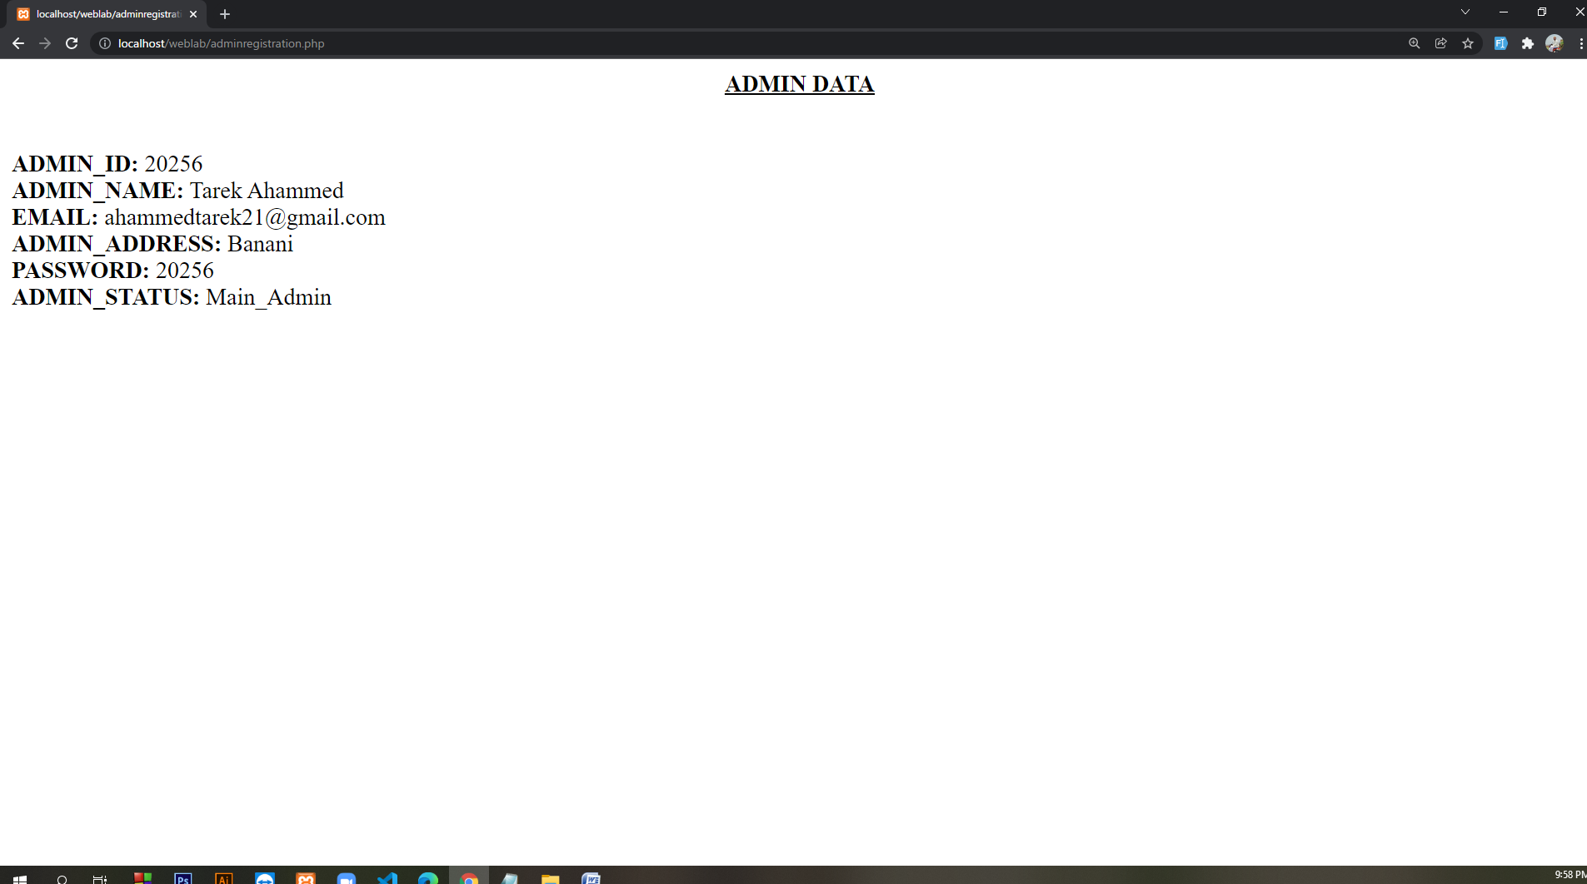

<?php

$con = mysqli_connect('localhost', 'root', '', 'rms');

if (isset($_POST['button'])) {

$aid = $_POST['aid'];

$aname = $_POST['aname'];

$email = $_POST['email'];

$adadrs = $_POST['adadrs'];

$adpass = $_POST['adpass'];

$as = $_POST['as'];

}

echo "<center><b><u> ADMIN DATA</u> </b></center>";

echo "</br>";

echo "</br>";

echo "<b>ADMIN_ID:</b> $aid";

echo "</br>";

echo "<b>ADMIN_NAME:</b> $aname";

echo "</br>";

echo "<b>EMAIL:</b> $email";

echo "</br>";

echo "<b>ADMIN_ADDRESS:</b> $adadrs";

echo "</br>";

echo "<b>PASSWORD:</b> $adpass";

echo "</br>";

echo "<b>ADMIN_STATUS:</b> $as";

echo "</br>";

$sql = "insert into admin_table (admin_id,admin_name,email,admin_address,password,admin_status)values('$aid','$aname','$email','$adadrs','$adpass','$as')";

mysqli_query($con, $sql);

**ABOUT**

**about.html**

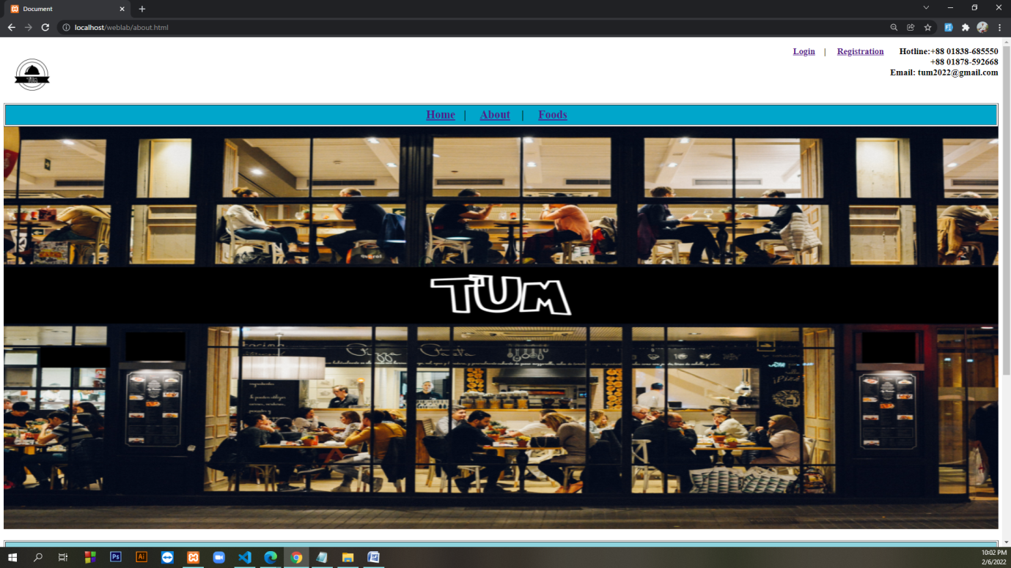

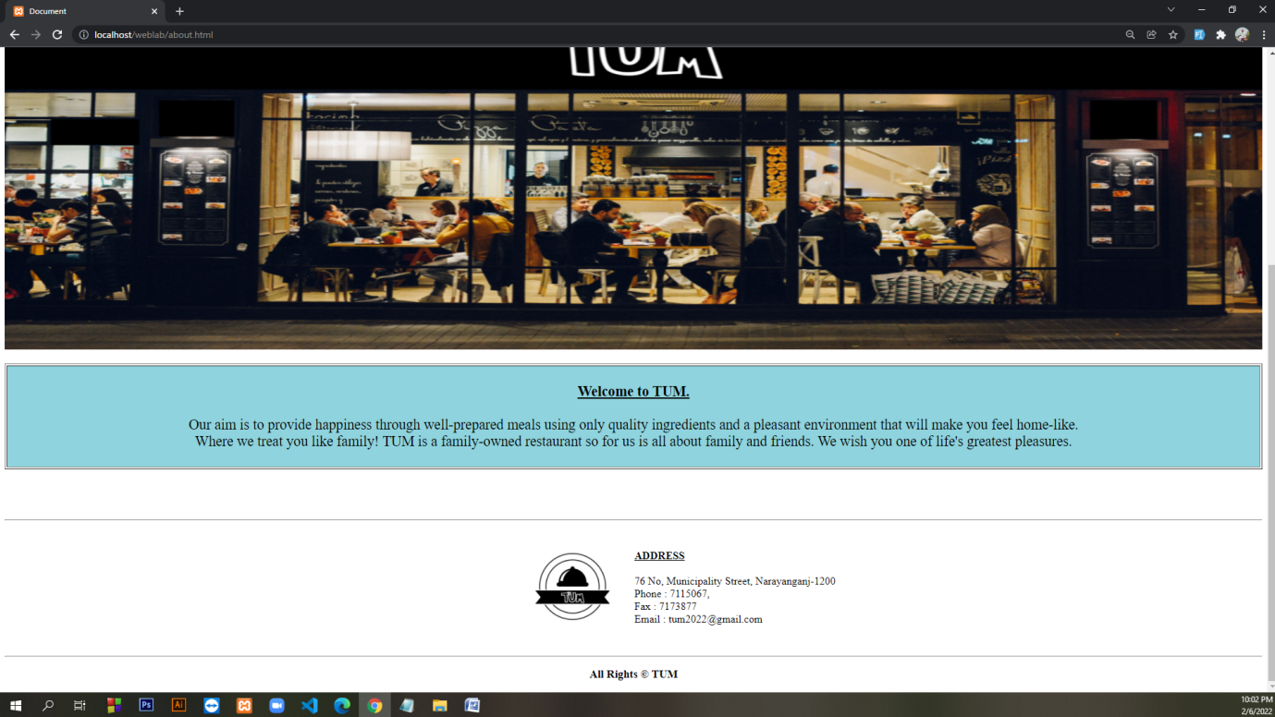

<!DOCTYPE html>

<html lang="en">

<head>

<meta charset="UTF-8">

<meta http-equiv="X-UA-Compatible" content="IE=edge">

<meta name="viewport" content="width=device-width, initial-scale=1.0">

<title>Document</title>

</head>

<body>

<a href="rms.html"><img align="left" height="120" width="120" src="logo.jpg"> </a>

<h3 align="right"><a href="login.html">Login</a> &nbsp&nbsp&nbsp| &nbsp&nbsp&nbsp <a

href="registration.html">Registration</a>

&nbsp&nbsp&nbsp&nbsp&nbsp&nbspHotline:+88 01838-685550 </br> +88 01878-592668 <br>

Email: tum2022@gmail.com </h3>

</br>

<table border="2" height="50" width="100%">

<tr height="100%" width="100%">

<td bgcolor=#00a6cb>

<center>

<font size="5">

<b>

<a href="rms.html">Home</a>&nbsp&nbsp&nbsp| &nbsp&nbsp&nbsp

<a href="about.html">About</a> &nbsp&nbsp&nbsp| &nbsp&nbsp&nbsp

<a href="food.html">Foods</a>&nbsp&nbsp&nbsp

</b>

</font>

</center>

</td>

</tr>

</table>

<center><img height="850" width="100%" src="TUM COVER.jpg"></center>

</br>

<table border="2" height="50" width="100%">

<tr height="100%" width="100%">

<td bgcolor=#8ed3dd>

<center>

<font size="5">

<br> <b> <u> Welcome to TUM.</u></b><br></br> Our aim is to provide happiness through

well-prepared meals using only quality ingredients and a

pleasant environment that will make you feel home-like.

<br>Where we treat you like family!

TUM is a family-owned restaurant so for us is all about

family and friends. We wish you one of life's greatest pleasures. </br></br>

</font>

</center>

</td>

</tr>

</table>

</br></br></br></br>

<hr>

<table border="0" height="10%" width="100%">

<tr>

<td height="20%" width="50%" bgcolor="white">

<DIV align="right"><a href="rms.html"><img height="200" width="200" src="logo.jpg"></a></DIV>

</td>

<td height="20%" width="50%" bgcolor="white">

<font size="4">

<DIV align="left">

</br> <b><u> ADDRESS</u></b> </br> </br>

</DIV>

76 No, Municipality Street, Narayanganj-1200</br>

Phone : 7115067, </br>

Fax : 7173877</br>

Email : tum2022@gmail.com</br></br>

</font>

</align>

</center>

</td>

</tr>

</table>

<hr>

<h3 align="center">All Rights &copy; TUM </h3>

</body>

</html>

**FOODS**

**food.html**

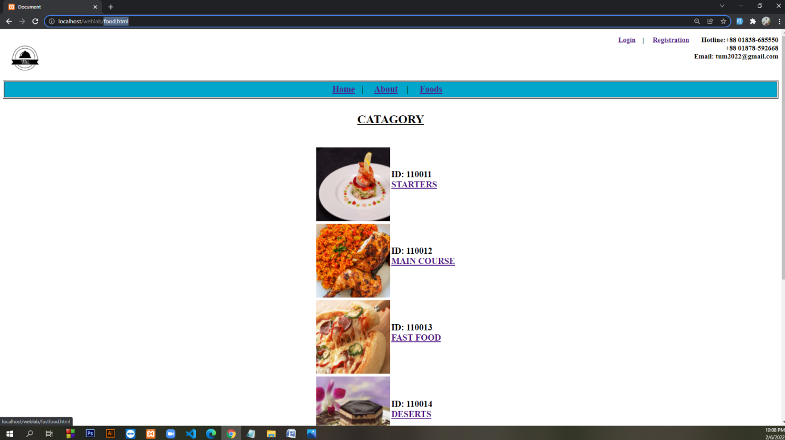

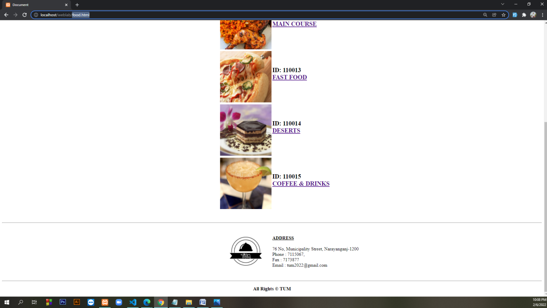

<!DOCTYPE html>

<html lang="en">

<head>

<meta charset="UTF-8">

<meta http-equiv="X-UA-Compatible" content="IE=edge">

<meta name="viewport" content="width=device-width, initial-scale=1.0">

<title>Document</title>

</head>

<body>

<a href="rms.html"><img align="left" height="120" width="120" src="logo.jpg"> </a>

<h3 align="right"><a href="login.html">Login</a> &nbsp&nbsp&nbsp| &nbsp&nbsp&nbsp <a

href="registration.html">Registration</a>

&nbsp&nbsp&nbsp&nbsp&nbsp&nbspHotline:+88 01838-685550 </br> +88 01878-592668 <br>

Email: tum2022@gmail.com </h3>

</br>

<table border="2" height="50" width="100%">

<tr height="100%" width="100%">

<td bgcolor=#00a6cb>

<center>

<font size="5">

<b>

<a href="rms.html">Home</a>&nbsp&nbsp&nbsp| &nbsp&nbsp&nbsp

<a href="about.html">About</a> &nbsp&nbsp&nbsp| &nbsp&nbsp&nbsp

<a href="food.html">Foods</a>&nbsp&nbsp&nbsp

</b>

</font>

</center>

</td>

</tr>

</table>

<br><br>

<font size="6">

<center><u><b>CATAGORY</b></u></center>

</font>

<br><br>

<table border="0" height="auto" width="100%">

<tr>

<td height="20%" width="50%" bgcolor="white">

<DIV align="right"><a href="starters.html"><img height="200" width="200"

src="jenkinsons-starter-prawn-salad.jpg"></a></DIV>

</td>

<td height="20%" width="50%" bgcolor="white">

<font size="5">

<DIV align="left">

</br> </br><b>ID: 110011</b><br>

<a href="starters.html"><b>STARTERS</b></a> </br> </br>

</DIV>

</br></br>

</font>

</align>

</center>

</td>

</tr>

<tr>

<td height="20%" width="50%" bgcolor="white">

<DIV align="right"><a href="maincourse.html"><img height="200" width="200"

src="gluten-free-peri-peri-chicken-recipe-spicy-rice-low-fodmap-dairy-free-4-600x588.jpg"></a></DIV>

</td>

<td height="20%" width="50%" bgcolor="white">

<font size="5">

<DIV align="left">

</br> </br><b>ID: 110012</b><br>

<a href="maincourse.html"><b> MAIN COURSE</b></a> </br> </br>

</DIV>

</br></br>

</font>

</align>

</center>

</td>

</tr>

<tr>

<td height="20%" width="50%" bgcolor="white">

<DIV align="right"><a href="fastfood.html"><img height="200" width="200"

src="Food_Pizza_Tasty_Pizza_011917_.jpg"></a></DIV>

</td>

<td height="20%" width="50%" bgcolor="white">

<font size="5">

<DIV align="left">

</br> </br><b>ID: 110013</b><br>

<a href="fastfood.html"><b> FAST FOOD</b></a> </br> </br>

</DIV>

</br></br>

</font>

</align>

</center>

</td>

</tr>

<tr>

<td height="20%" width="50%" bgcolor="white">

<DIV align="right"><a href="desert.html"><img height="200" width="200"

src="French-Desserts.jpg"></a></DIV>

</td>

<td height="20%" width="50%" bgcolor="white">

<font size="5">

<DIV align="left">

</br> </br><b>ID: 110014</b><br>

<a href="desert.html"><b> DESERTS</b></a> </br> </br>

</DIV>

</br></br>

</font>

</align>

</center>

</td>

</tr>

<tr>

<td height="20%" width="50%" bgcolor="white">

<DIV align="right"><a href="coffee.html"><img height="200" width="200"

src="margarita.jpg"></a></DIV>

</td>

<td height="20%" width="50%" bgcolor="white">

<font size="5">

<DIV align="left">

</br> </br><b>ID: 110015</b><br>

<a href="coffee.html"><b> COFFEE & DRINKS</b></a> </br> </br>

</DIV>

</br></br>

</font>

</align>

</center>

</td>

</tr>

</table>

<br><br>

<hr>

<table border="0" height="10%" width="100%">

<tr>

<td height="20%" width="50%" bgcolor="white">

<DIV align="right"><a href="rms.html"><img height="200" width="200" src="logo.jpg"></a></DIV>

</td>

<td height="20%" width="50%" bgcolor="white">

<font size="4">

<DIV align="left">

</br> <b><u> ADDRESS</u></b> </br> </br>

</DIV>

76 No, Municipality Street, Narayanganj-1200</br>

Phone : 7115067, </br>

Fax : 7173877</br>

Email : tum2022@gmail.com</br></br>

</font>

</align>

</center>

</td>

</tr>

</table>

<hr>

<h3 align="center">All Rights &copy; TUM </h3>

</body>

</html>

**starters.html**

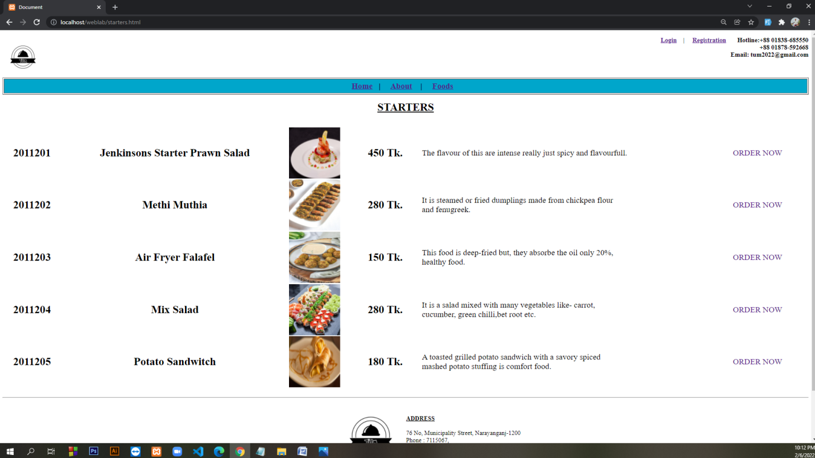

<!DOCTYPE html>

<html lang="en">

<head>

<meta charset="UTF-8">

<meta http-equiv="X-UA-Compatible" content="IE=edge">

<meta name="viewport" content="width=device-width, initial-scale=1.0">

<title>Document</title>

<link rel="stylesheet" href="style.css">

</head>

<body>

<body>

<a href="rms.html"><img align="left" height="120" width="120" src="logo.jpg"> </a>

<h3 align="right"><a href="login.html">Login</a> &nbsp&nbsp&nbsp| &nbsp&nbsp&nbsp <a

href="registration.html">Registration</a>

&nbsp&nbsp&nbsp&nbsp&nbsp&nbspHotline:+88 01838-685550 </br> +88 01878-592668 <br>

Email: tum2022@gmail.com </h3>

</br>

<table border="2" height="50" width="100%">

<tr height="100%" width="100%">

<td bgcolor=#00a6cb>

<center>

<font size="5">

<b>

<a href="rms.html">Home</a>&nbsp&nbsp&nbsp| &nbsp&nbsp&nbsp

<a href="about.html">About</a> &nbsp&nbsp&nbsp| &nbsp&nbsp&nbsp

<a href="food.html">Foods</a>&nbsp&nbsp&nbsp

</b>

</font>

</center>

</td>

</tr>

</table>

<br>

<center>

<font size="6"><u><b>STARTERS</b></u></font>

</center> </br></br>

<table border="0" height="auto" width="100%">

<tr height="100%" width="100%">

<td>

<center>

<font size="6"><b>2011201</b></font>

</center>

</td>

<td>

<center>

<font size="6"><b> Jenkinsons Starter Prawn Salad</b></font>

</center>

</td>

<td <center>

<font size="5"><img align="left" height="150" width="150" src="jenkinsons-starter-prawn-salad.jpg">

</font>

</center>

</td>

<td <center>

<font size="6"><b>450 Tk.</b></font>

</center>

</td>

<td <center>

<font size="5">

The flavour of this are intense really just spicy and flavourfull.

</font>

</center>

</td>

<td <center>

<font size="5"><a class="abc" href="login.html">ORDER NOW</a></font>

</center>

</td>

</tr>

<tr height="100%" width="100%">

<td>

<center>

<font size="6"><b>2011202</b></font>

</center>

</td>

<td>

<center>

<font size="6"><b> Methi Muthia</b></font>

</center>

</td>

<td <center>

<font size="5"><img align="left" height="150" width="150" src="methi-muthia-recipe-1.jpg">

</font>

</center>

</td>

<td <center>

<font size="6"><b>280 Tk.</b></font>

</center>

</td>

<td <center>

<font size="5">

It is steamed or fried dumplings made from chickpea flour <br> and fenugreek.

</font>

</center>

</td>

<td <center>

<font size="5"><a class="abc" href="login.html">ORDER NOW</a></font>

</center>

</td>

</tr>

<tr height="100%" width="100%">

<td>

<center>

<font size="6"><b>2011203</b></font>

</center>

</td>

<td>

<center>

<font size="6"><b> Air Fryer Falafel</b></font>

</center>

</td>

<td <center>

<font size="5"><img align="left" height="150" width="150" src="Air-fryer-falafel.jpg">

</font>

</center>

</td>

<td <center>

<font size="6"><b>150 Tk.</b></font>

</center>

</td>

<td <center>

<font size="5">

This food is deep-fried but, they absorbe the oil only 20%,<br> healthy food.

</font>

</center>

</td>

<td <center>

<font size="5"><a class="abc" href="login.html">ORDER NOW</a></font>

</center>

</td>

</tr>

<tr height="100%" width="100%">

<td>

<center>

<font size="6"><b>2011204</b></font>

</center>

</td>

<td>

<center>

<font size="6"><b> Mix Salad</b></font>

</center>

</td>

<td <center>

<font size="5"><img align="left" height="150" width="150"

src="09f08f0886c39e2709550b1cdc18366b.jpg">

</font>

</center>

</td>

<td <center>

<font size="6"><b>280 Tk.</b></font>

</center>

</td>

<td <center>

<font size="5">

It is a salad mixed with many vegetables like- carrot, <br>cucumber, green chilli,bet root etc.

</font>

</center>

</td>

<td <center>

<font size="5"><a class ="abc" href="login.html">ORDER NOW</a></font>

</center>

</td>

</tr>

<tr height="100%" width="100%">

<td>

<center>

<font size="6"><b>2011205</b></font>

</center>

</td>

<td>

<center>

<font size="6"><b> Potato Sandwitch</b></font>

</center>

</td>

<td <center>

<font size="5"><img align="left" height="150" width="150"

src="d8e3bb9b-b19f-40d8-9e89-76e30111c815.jpg">

</font>

</center>

</td>

<td <center>

<font size="6"><b>180 Tk.</b></font>

</center>

</td>

<td <center>

<font size="5">

A toasted grilled potato sandwich with a savory spiced <br>mashed potato stuffing is

comfort food.

</font>

</center>

</td>

<td <center>

<font size="5"><a class ="abc" href="login.html">ORDER NOW</a></font>

</center>

</td>

</tr>

</table>

<br>

<hr>

<table border="0" height="10%" width="100%">

<tr>

<td height="20%" width="50%" bgcolor="white">

<DIV align="right"><a href="rms.html"><img height="200" width="200" src="logo.jpg"></a></DIV>

</td>

<td height="20%" width="50%" bgcolor="white">

<font size="4">

<DIV align="left">

</br> <b><u> ADDRESS</u></b> </br> </br>

</DIV>

76 No, Municipality Street, Narayanganj-1200</br>

Phone : 7115067, </br>

Fax : 7173877</br>

Email : tum2022@gmail.com</br></br>

</font>

</align>

</center>

</td>

</tr>

</table>

<hr>

<h3 align="center">All Rights &copy; TUM </h3>

</body></html>

**maincourse.html**

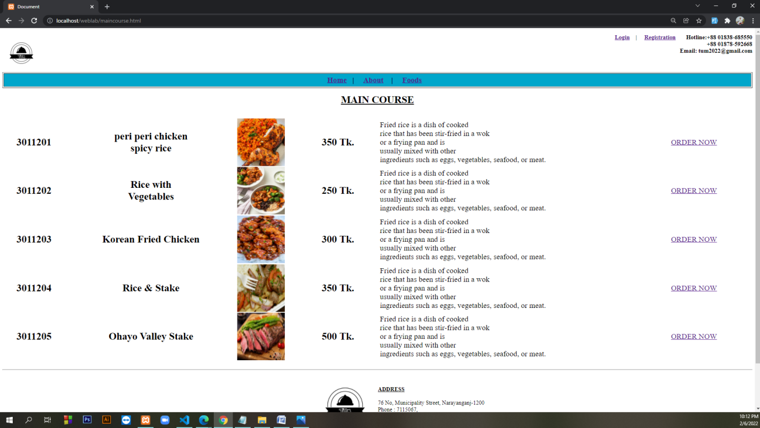

<!DOCTYPE html>

<html lang="en">

<head>

<meta charset="UTF-8">

<meta http-equiv="X-UA-Compatible" content="IE=edge">

<meta name="viewport" content="width=device-width, initial-scale=1.0">

<title>Document</title>

</head>

<body>

<body>

<a href="rms.html"><img align="left" height="120" width="120" src="logo.jpg"> </a>

<h3 align="right"><a href="login.html">Login</a> &nbsp&nbsp&nbsp| &nbsp&nbsp&nbsp <a

href="registration.html">Registration</a>

&nbsp&nbsp&nbsp&nbsp&nbsp&nbspHotline:+88 01838-685550 </br> +88 01878-592668 <br>

Email: tum2022@gmail.com </h3>

</br>

<table border="2" height="50" width="100%">

<tr height="100%" width="100%">

<td bgcolor=#00a6cb>

<center>

<font size="5">

<b>

<a href="rms.html">Home</a>&nbsp&nbsp&nbsp| &nbsp&nbsp&nbsp

<a href="about.html">About</a> &nbsp&nbsp&nbsp| &nbsp&nbsp&nbsp

<a href="food.html">Foods</a>&nbsp&nbsp&nbsp

</b>

</font>

</center>

</td>

</tr>

</table>

<br>

<center>

<font size="6"><u><b>MAIN COURSE</b></u></font>

</center> </br></br>

<table border="0" height="auto" width="100%">

<tr height="100%" width="100%">

<td>

<center>

<font size="6"><b>3011201</b></font>

</center>

</td>

<td>

<center>

<font size="6"><b> peri peri chicken <br> spicy rice </b></font>

</center>

</td>

<td <center>

<font size="5"><img align="left" height="150" width="150" src="gluten-free-peri-peri-chicken-recipe-spicy-rice-low-fodmap-dairy-free-4-600x588.jpg">

</font>

</center>

</td>

<td <center>

<font size="6"><b>350 Tk.</b></font>

</center>

</td>

<td <center>

<font size="5">

Fried rice is a dish of cooked <br> rice that has been stir-fried in a wok<br> or a frying pan

and is

<br>usually mixed with other<br> ingredients such as

eggs, vegetables, seafood, or meat.

</font>

</center>

</td>

<td <center>

<font size="5"><a href="login.html">ORDER NOW</a></font>

</center>

</td>

</tr>

<tr height="100%" width="100%">

<td>

<center>

<font size="6"><b>3011202</b></font>

</center>

</td>

<td>

<center>

<font size="6"><b> Rice with <br>Vegetables</b></font>

</center>

</td>

<td <center>

<font size="5"><img align="left" height="150" width="150" src="d1ad1079a711cbace57f86e4a8785a6b2ff90187.jpeg">

</font>

</center>

</td>

<td <center>

<font size="6"><b>250 Tk.</b></font>

</center>

</td>

<td <center>

<font size="5">

Fried rice is a dish of cooked <br> rice that has been stir-fried in a wok<br> or a frying pan

and is

<br>usually mixed with other<br> ingredients such as

eggs, vegetables, seafood, or meat.

</font>

</center>

</td>

<td <center>

<font size="5"><a href="login.html">ORDER NOW</a></font>

</center>

</td>

</tr>

<tr height="100%" width="100%">

<td>

<center>

<font size="6"><b>3011203</b></font>

</center>

</td>

<td>

<center>

<font size="6"><b> Korean Fried Chicken </b></font>

</center>

</td>

<td <center>

<font size="5"><img align="left" height="150" width="150" src="Korean-Fried-Chicken-3.jpg">

</font>

</center>

</td>

<td <center>

<font size="6"><b>300 Tk.</b></font>

</center>

</td>

<td <center>

<font size="5">

Fried rice is a dish of cooked <br> rice that has been stir-fried in a wok<br> or a frying pan

and is

<br>usually mixed with other<br> ingredients such as

eggs, vegetables, seafood, or meat.

</font>

</center>

</td>

<td <center>

<font size="5"><a href="login.html">ORDER NOW</a></font>

</center>

</td>

</tr>

<tr height="100%" width="100%">

<td>

<center>

<font size="6"><b>3011204</b></font>

</center>

</td>

<td>

<center>

<font size="6"><b> Rice & Stake</b></font>

</center>

</td>

<td <center>

<font size="5"><img align="left" height="150" width="150" src="la-dd-study-fast-food-restaurant-20150720.jpg">

</font>

</center>

</td>

<td <center>

<font size="6"><b>350 Tk.</b></font>

</center>

</td>

<td <center>

<font size="5">

Fried rice is a dish of cooked <br> rice that has been stir-fried in a wok<br> or a frying pan

and is

<br>usually mixed with other<br> ingredients such as

eggs, vegetables, seafood, or meat.

</font>

</center>

</td>

<td <center>

<font size="5"><a href="login.html">ORDER NOW</a></font>

</center>

</td>

</tr>

<tr height="100%" width="100%">

<td>

<center>

<font size="6"><b>3011205</b></font>

</center>

</td>

<td>

<center>

<font size="6"><b> Ohayo Valley Stake </b></font>

</center>

</td>

<td <center>

<font size="5"><img align="left" height="150" width="150" src="Ohayo-Valley-741x555.jpg">

</font>

</center>

</td>

<td <center>

<font size="6"><b>500 Tk.</b></font>

</center>

</td>

<td <center>

<font size="5">

Fried rice is a dish of cooked <br> rice that has been stir-fried in a wok<br> or a frying pan

and is

<br>usually mixed with other<br> ingredients such as

eggs, vegetables, seafood, or meat.

</font>

</center>

</td>

<td <center>

<font size="5"><a href="login.html">ORDER NOW</a></font>

</center>

</td>

</tr>

</table>

<br>

<hr>

<table border="0" height="10%" width="100%">

<tr>

<td height="20%" width="50%" bgcolor="white">

<DIV align="right"><a href="rms.html"><img height="200" width="200" src="logo.jpg"></a></DIV>

</td>

<td height="20%" width="50%" bgcolor="white">

<font size="4">

<DIV align="left">

</br> <b><u> ADDRESS</u></b> </br> </br>

</DIV>

76 No, Municipality Street, Narayanganj-1200</br>

Phone : 7115067, </br>

Fax : 7173877</br>

Email : tum2022@gmail.com</br></br>

</font>

</align>

</center>

</td>

</tr>

</table>

<hr>

<h3 align="center">All Rights &copy; TUM </h3>

</body>

</html>

**fastfood.html**

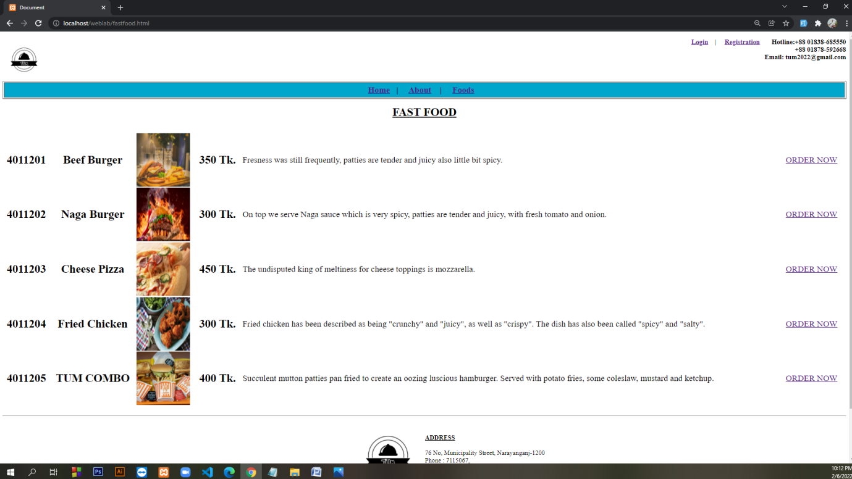

<!DOCTYPE html>

<html lang="en">

<head>

<meta charset="UTF-8">

<meta http-equiv="X-UA-Compatible" content="IE=edge">

<meta name="viewport" content="width=device-width, initial-scale=1.0">

<title>Document</title>

</head>

<body>

<a href="rms.html"><img align="left" height="120" width="120" src="logo.jpg"> </a>

<h3 align="right"><a href="login.html">Login</a> &nbsp&nbsp&nbsp| &nbsp&nbsp&nbsp <a

href="registration.html">Registration</a>

&nbsp&nbsp&nbsp&nbsp&nbsp&nbspHotline:+88 01838-685550 </br> +88 01878-592668 <br>

Email: tum2022@gmail.com </h3>

</br>

<table border="2" height="50" width="100%">

<tr height="100%" width="100%">

<td bgcolor=#00a6cb>

<center>

<font size="5">

<b>

<a href="rms.html">HOME</a>&nbsp&nbsp&nbsp| &nbsp&nbsp&nbsp

<a href="role.html">ROLE</a> &nbsp&nbsp&nbsp| &nbsp&nbsp&nbsp

<a href="salesadmin.html">SALES</a>&nbsp&nbsp&nbsp | &nbsp&nbsp&nbsp

<a href="foodsadmin.html">FOOD</a>&nbsp&nbsp&nbsp

</b>

</font>

</center>

</td>

</tr>

</table>

</br></br></br></br></br>

<table border="0" height="50" width="100%">

<tr height="100%" width="100%">

<td bgcolor="lime">

<center>

<font size="5">

<b>

<a href="insertfood.html">INSERT FOOD</a>&nbsp&nbsp&nbsp | &nbsp&nbsp&nbsp

<a href="update_food.php">UPDATE FOOD</a>&nbsp&nbsp&nbsp| &nbsp&nbsp&nbsp

<a href="delete_food.php">DELETE FOOD</a> &nbsp&nbsp&nbsp| &nbsp&nbsp&nbsp

<a href="display_food.php">DISPLAY FOOD</a>&nbsp&nbsp&nbsp

</b>

</font>

</center>

</td>

</tr>

</table>

</br></br></br></br></br></br></br></br></br></br>

<hr>

<table border="0" height="10%" width="100%">

<tr>

<td height="20%" width="50%" bgcolor="white">

<DIV align="right"><a href="rms.html"><img height="200" width="200" src="logo.jpg"></a></DIV>

</td>

<td height="20%" width="50%" bgcolor="white">

<font size="4">

<DIV align="left">

</br> <b><u> ADDRESS</u></b> </br> </br>

</DIV>

76 No, Municipality Street, Narayanganj-1200</br>

Phone : 7115067, </br>

Fax : 7173877</br>

Email : tum2022@gmail.com</br></br>

</font>

</align>

</center>

</td>

</tr>

</table>

<hr>

<h3 align="center">All Rights &copy; TUM </h3>

</body>

</html>

**desert.html**

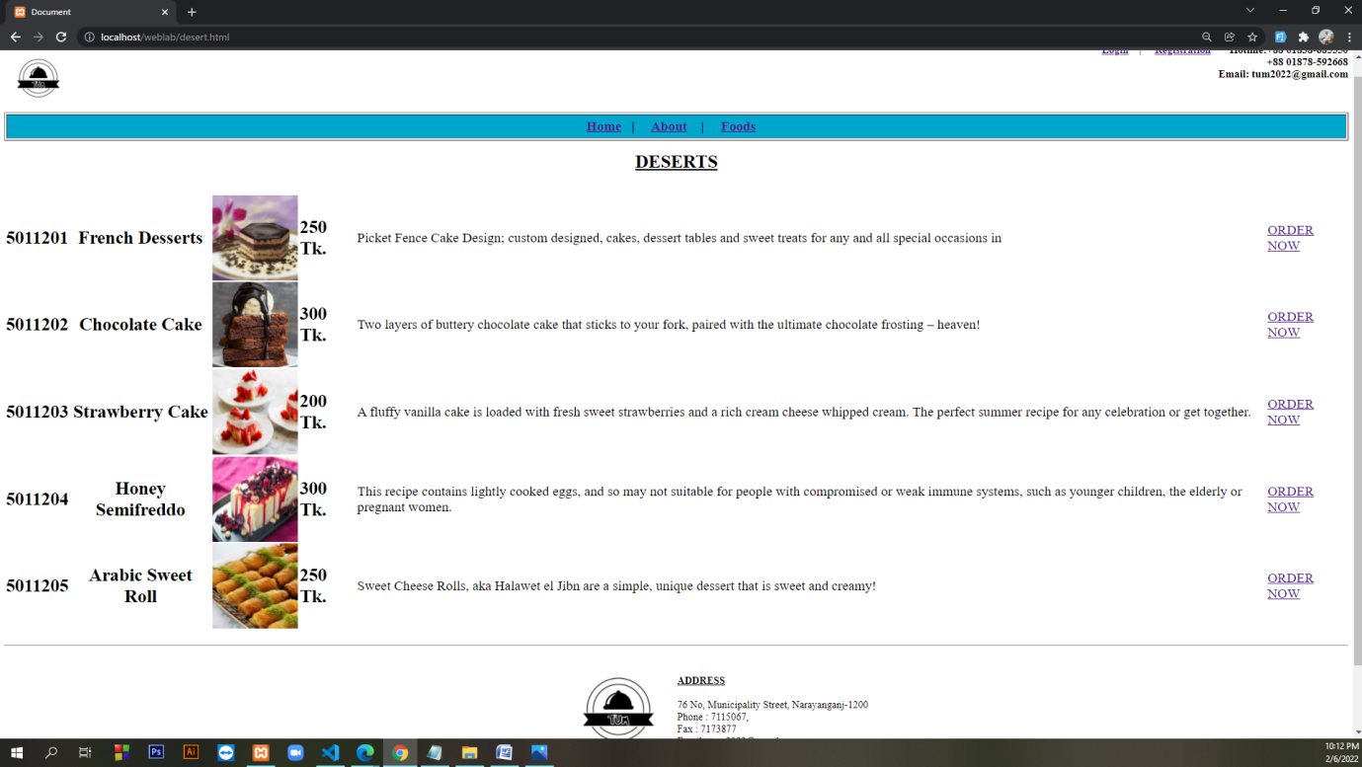

<!DOCTYPE html>

<html lang="en">

<head>

<meta charset="UTF-8">

<meta http-equiv="X-UA-Compatible" content="IE=edge">

<meta name="viewport" content="width=device-width, initial-scale=1.0">

<title>Document</title>

</head>

<body>

<body>

<a href="rms.html"><img align="left" height="120" width="120" src="logo.jpg"> </a>

<h3 align="right"><a href="login.html">Login</a> &nbsp&nbsp&nbsp| &nbsp&nbsp&nbsp <a

href="registration.html">Registration</a>

&nbsp&nbsp&nbsp&nbsp&nbsp&nbspHotline:+88 01838-685550 </br> +88 01878-592668 <br>

Email: tum2022@gmail.com </h3>

</br>

<table border="2" height="50" width="100%">

<tr height="100%" width="100%">

<td bgcolor=#00a6cb>

<center>

<font size="5">

<b>

<a href="rms.html">Home</a>&nbsp&nbsp&nbsp| &nbsp&nbsp&nbsp

<a href="about.html">About</a> &nbsp&nbsp&nbsp| &nbsp&nbsp&nbsp

<a href="food.html">Foods</a>&nbsp&nbsp&nbsp

</b>

</font>

</center>

</td>

</tr>

</table>

<br>

<center>

<font size="6"><u><b>DESERTS</b></u></font>

</center> </br></br>

<table border="0" height="auto" width="100%">

<tr height="100%" width="100%">

<td>

<center>

<font size="6"><b>5011201</b></font>

</center>

</td>

<td>

<center>

<font size="6"><b>French Desserts </b></font>

</center>

</td>

<td <center>

<font size="5"><img align="left" height="150" width="150" src="French-Desserts.jpg">

</font>

</center>

</td>

<td <center>

<font size="6"><b>250 Tk.</b></font>

</center>

</td>

<td <center>

<font size="5">

Picket Fence Cake Design; custom designed, cakes, dessert tables and sweet treats for any and

all special occasions in

</font>

</center>

</td>

<td <center>

<font size="5"><a href="login.html">ORDER NOW</a></font>

</center>

</td>

</tr>

<tr height="100%" width="100%">

<td>

<center>

<font size="6"><b>5011202</b></font>

</center>

</td>

<td>

<center>

<font size="6"><b>Chocolate Cake</b></font>

</center>

</td>

<td <center>

<font size="5"><img align="left" height="150" width="150"

src="these-nutella-brownies-top-our-list-of-quick-and-easy-dessert-recipes.jpg">

</font>

</center>

</td>

<td <center>

<font size="6"><b>300 Tk.</b></font>

</center>

</td>

<td <center>

<font size="5">

Two layers of buttery chocolate cake that sticks to your fork,

paired with the ultimate chocolate frosting – heaven!

</font>

</center>

</td>

<td <center>

<font size="5"><a href="login.html">ORDER NOW</a></font>

</center>

</td>

</tr>

<tr height="100%" width="100%">

<td>

<center>

<font size="6"><b>5011203</b></font>

</center>

</td>

<td>

<center>

<font size="6"><b> Strawberry Cake </b></font>

</center>

</td>

<td <center>

<font size="5"><img align="left" height="150" width="150" src="1393874276855.jpeg">

</font>

</center>

</td>

<td <center>

<font size="6"><b>200 Tk.</b></font>

</center>

</td>

<td <center>

<font size="5">

A fluffy vanilla cake is loaded with fresh sweet strawberries and a rich cream

cheese whipped cream. The perfect summer recipe for any celebration or get together.

</font>

</center>

</td>

<td <center>

<font size="5"><a href="login.html">ORDER NOW</a></font>

</center>

</td>

</tr>

<tr height="100%" width="100%">

<td>

<center>

<font size="6"><b>5011204</b></font>

</center>

</td>

<td>

<center>

<font size="6"><b> Honey Semifreddo</b></font>

</center>

</td>

<td <center>

<font size="5"><img align="left" height="150" width="150"

src="__opt__aboutcom__coeus__resources__content_migration__serious_eats__seriouseats.com__2018__06__20180626-semifreddo-vicky-wasik-12-349eb45f52654ce588403bd0fbcbfce1.jpg">

</font>

</center>

</td>

<td <center>

<font size="6"><b>300 Tk.</b></font>

</center>

</td>

<td <center>

<font size="5">

This recipe contains lightly cooked eggs, and so may not suitable for people

with compromised or weak immune systems, such as younger children, the elderly

or pregnant women.

</font>

</center>

</td>

<td <center>

<font size="5"><a href="login.html">ORDER NOW</a></font>

</center>

</td>

</tr>

<tr height="100%" width="100%">

<td>

<center>

<font size="6"><b>5011205</b></font>

</center>

</td>

<td>

<center>

<font size="6"><b> Arabic Sweet Roll </b></font>

</center>

</td>

<td <center>

<font size="5"><img align="left" height="150" width="150"

src="Ricotta-Kunafa-Rolls-1-e1577389905530.jpg">

</font>

</center>

</td>

<td <center>

<font size="6"><b>250 Tk.</b></font>

</center>

</td>

<td <center>

<font size="5">

Sweet Cheese Rolls, aka Halawet el Jibn are a simple, unique dessert that is

sweet and creamy!

</font>

</center>

</td>

<td <center>

<font size="5"><a href="login.html">ORDER NOW</a></font>

</center>

</td>

</tr>

</table>

<br>

<hr>

<table border="0" height="10%" width="100%">

<tr>

<td height="20%" width="50%" bgcolor="white">

<DIV align="right"><a href="rms.html"><img height="200" width="200" src="logo.jpg"></a></DIV>

</td>

<td height="20%" width="50%" bgcolor="white">

<font size="4">

<DIV align="left">

</br> <b><u> ADDRESS</u></b> </br> </br>

</DIV>

76 No, Municipality Street, Narayanganj-1200</br>

Phone : 7115067, </br>

Fax : 7173877</br>

Email : tum2022@gmail.com</br></br>

</font>

</align>

</center>

</td>

</tr>

</table>

<hr>

<h3 align="center">All Rights &copy; TUM </h3>

</body>

</html>

**coffee.html**

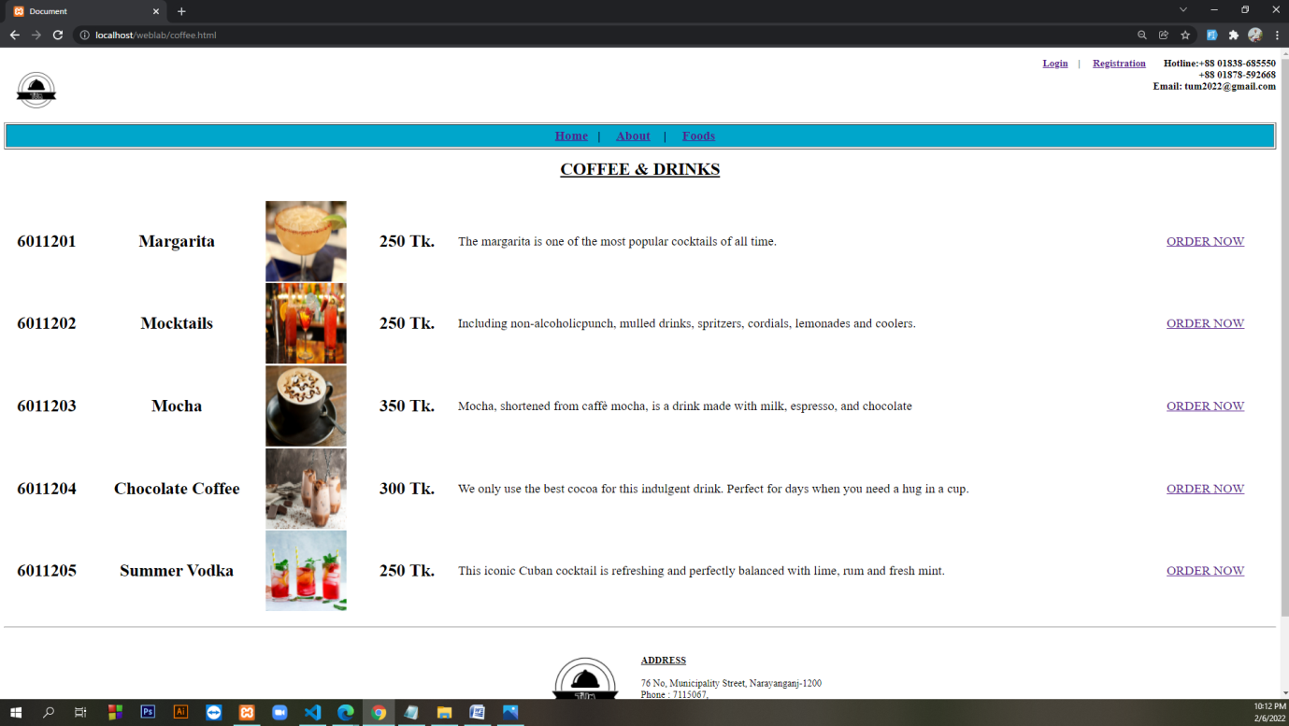

<!DOCTYPE html>

<html lang="en">

<head>

<meta charset="UTF-8">

<meta http-equiv="X-UA-Compatible" content="IE=edge">

<meta name="viewport" content="width=device-width, initial-scale=1.0">

<title>Document</title>

</head>

<body>

<body>

<a href="rms.html"><img align="left" height="120" width="120" src="logo.jpg"> </a>

<h3 align="right"><a href="login.html">Login</a> &nbsp&nbsp&nbsp| &nbsp&nbsp&nbsp <a

href="registration.html">Registration</a>

&nbsp&nbsp&nbsp&nbsp&nbsp&nbspHotline:+88 01838-685550 </br> +88 01878-592668 <br>

Email: tum2022@gmail.com </h3>

</br>

<table border="2" height="50" width="100%">

<tr height="100%" width="100%">

<td bgcolor=#00a6cb>

<center>

<font size="5">

<b>

<a href="rms.html">Home</a>&nbsp&nbsp&nbsp| &nbsp&nbsp&nbsp

<a href="about.html">About</a> &nbsp&nbsp&nbsp| &nbsp&nbsp&nbsp

<a href="food.html">Foods</a>&nbsp&nbsp&nbsp

</b>

</font>

</center>

</td>

</tr>

</table>

<br>

<center>

<font size="6"><u><b>COFFEE & DRINKS</b></u></font>

</center> </br></br>

<table border="0" height="auto" width="100%">

<tr height="100%" width="100%">

<td>

<center>

<font size="6"><b>6011201</b></font>

</center>

</td>

<td>

<center>

<font size="6"><b>Margarita </b></font>

</center>

</td>

<td <center>

<font size="5"><img align="left" height="150" width="150" src="margarita.jpg">

</font>

</center>

</td>

<td <center>

<font size="6"><b>250 Tk.</b></font>

</center>

</td>

<td <center>

<font size="5">

The margarita is one of the most popular

cocktails of all time.

</font>

</center>

</td>

<td <center>

<font size="5"><a href="login.html">ORDER NOW</a></font>

</center>

</td>

</tr>

<tr height="100%" width="100%">

<td>

<center>

<font size="6"><b>6011202</b></font>

</center>

</td>

<td>

<center>

<font size="6"><b>Mocktails</b></font>

</center>

</td>

<td <center>

<font size="5"><img align="left" height="150" width="150" src="Mocktails.jpg">

</font>

</center>

</td>

<td <center>

<font size="6"><b>250 Tk.</b></font>

</center>

</td>

<td <center>

<font size="5">

Including non-alcoholicpunch, mulled drinks, spritzers, cordials, lemonades and coolers.

</font>

</center>

</td>

<td <center>

<font size="5"><a href="login.html">ORDER NOW</a></font>

</center>

</td>

</tr>

<tr height="100%" width="100%">

<td>

<center>

<font size="6"><b>6011203</b></font>

</center>

</td>

<td>

<center>

<font size="6"><b> Mocha </b></font>

</center>

</td>

<td <center>

<font size="5"><img align="left" height="150" width="150" src="mocha.jpg">

</font>

</center>

</td>

<td <center>

<font size="6"><b>350 Tk.</b></font>

</center>

</td>

<td <center>

<font size="5">

Mocha, shortened from caffè mocha, is a drink made with milk, espresso, and

chocolate

</font>

</center>

</td>

<td <center>

<font size="5"><a href="login.html">ORDER NOW</a></font>

</center>

</td>

</tr>

<tr height="100%" width="100%">

<td>

<center>

<font size="6"><b>6011204</b></font>

</center>

</td>

<td>

<center>

<font size="6"><b> Chocolate Coffee</b></font>

</center>

</td>

<td <center>

<font size="5"><img align="left" height="150" width="150"

src="NEFF_feature_summer_iced_chocolate-1024x576.png">

</font>

</center>

</td>

<td <center>

<font size="6"><b>300 Tk.</b></font>

</center>

</td>

<td <center>

<font size="5">

We only use the best cocoa for this indulgent drink.

Perfect for days when you need a hug in a cup.

</font>

</center>

</td>

<td <center>

<font size="5"><a href="login.html">ORDER NOW</a></font>

</center>

</td>

</tr>

<tr height="100%" width="100%">

<td>

<center>

<font size="6"><b>6011205</b></font>

</center>

</td>

<td>

<center>

<font size="6"><b> Summer Vodka </b></font>

</center>

</td>

<td <center>

<font size="5"><img align="left" height="150" width="150" src="Vodka-Spritzer-011.jpg">

</font>

</center>

</td>

<td <center>

<font size="6"><b>250 Tk.</b></font>

</center>

</td>

<td <center>

<font size="5">

This iconic Cuban cocktail

is refreshing and perfectly balanced with lime, rum and fresh mint.

</font>

</center>

</td>

<td <center>

<font size="5"><a href="login.html">ORDER NOW</a></font>

</center>

</td>

</tr>

</table>

<br>

<hr>

<table border="0" height="10%" width="100%">

<tr>

<td height="20%" width="50%" bgcolor="white">

<DIV align="right"><a href="rms.html"><img height="200" width="200" src="logo.jpg"></a></DIV>

</td>

<td height="20%" width="50%" bgcolor="white">

<font size="4">

<DIV align="left">

</br> <b><u> ADDRESS</u></b> </br> </br>

</DIV>

76 No, Municipality Street, Narayanganj-1200</br>

Phone : 7115067, </br>

Fax : 7173877</br>

Email : tum2022@gmail.com</br></br>

</font>

</align>

</center>

</td>

</tr>

</table>

<hr>

<h3 align="center">All Rights &copy; TUM </h3>

</body>

</html>

**admin.html**

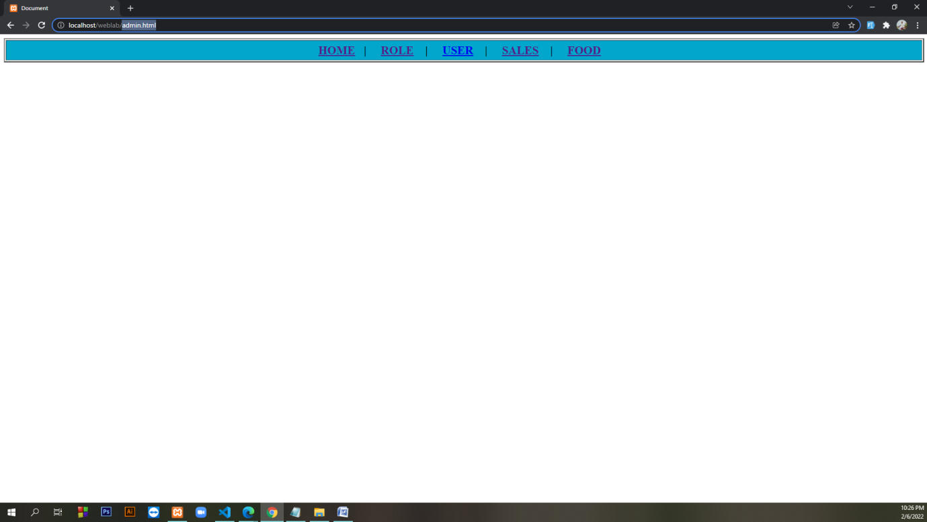

<!DOCTYPE html>

<html lang="en">

<head>

<meta charset="UTF-8">

<meta http-equiv="X-UA-Compatible" content="IE=edge">

<meta name="viewport" content="width=device-width, initial-scale=1.0">

<title>Document</title>

</head>

<body>

<table border="2" height="50" width="100%">

<tr height="100%" width="100%">

<td bgcolor=#00a6cb>

<center>

<font size="5">

<b>

<a href="rms.html">HOME</a>&nbsp&nbsp&nbsp| &nbsp&nbsp&nbsp

<a href="role.html">ROLE</a> &nbsp&nbsp&nbsp| &nbsp&nbsp&nbsp

<a href="useradmin.html">USER</a>&nbsp&nbsp&nbsp | &nbsp&nbsp&nbsp

<a href="salesadmin.html">SALES</a>&nbsp&nbsp&nbsp | &nbsp&nbsp&nbsp

<a href="foodsadmin.html">FOOD</a>&nbsp&nbsp&nbsp

</b>

</font>

</center>

</td>

</tr>

</table>

</body>

</html>

**ROLE**

**role.html**

<!DOCTYPE html>

<html lang="en">

<head>

<meta charset="UTF-8">

<meta http-equiv="X-UA-Compatible" content="IE=edge">

<meta name="viewport" content="width=device-width, initial-scale=1.0">

<title>Document</title>

</head>

<body>

<a href="rms.html"><img align="left" height="120" width="120" src="logo.jpg"> </a>

<h3 align="right"><a href="login.html">Login</a> &nbsp&nbsp&nbsp| &nbsp&nbsp&nbsp <a

href="registration.html">Registration</a>

&nbsp&nbsp&nbsp&nbsp&nbsp&nbspHotline:+88 01838-685550 </br> +88 01878-592668 <br>

Email: tum2022@gmail.com </h3>

</br>

<table border="2" height="50" width="100%">

<tr height="100%" width="100%">

<td bgcolor=#00a6cb>

<center>

<font size="5">

<b>

<a href="rms.html">HOME</a>&nbsp&nbsp&nbsp| &nbsp&nbsp&nbsp

<a href="role.html">ROLE</a> &nbsp&nbsp&nbsp| &nbsp&nbsp&nbsp

<a href="salesadmin.html">SALES</a>&nbsp&nbsp&nbsp | &nbsp&nbsp&nbsp

<a href="foodsadmin.html">FOOD</a>&nbsp&nbsp&nbsp

</b>

</font>

</center>

</td>

</tr>

</table>

</br></br></br></br></br>

<table border="0" height="auto" width="100%">

<tr>

<td height="20%" width="50%" bgcolor="white">

<form action="role.php" method="POST">

<center>

</br></br></br>

<font size="6"><u><b>ROLE DATA</b></u></font> </br></br>

<label><b>ROLE_ID:</b></label>

<input type="text" placeholder="Enter Your role_id here" name="roleid"> </br></br>

<label><b>ROLE_NAME:</b></label>

<input type="text" placeholder="Enter Your role_name here" name="rolename"> </br></br>

<input type="Submit" style="color:blue" value="submit" name="button">

&nbsp&nbsp&nbsp&nbsp</br></br>

</form>

</td>

</tr>

</table>

</br></br></br></br></br></br></br></br></br></br>

<hr>

<table border="0" height="10%" width="100%">

<tr>

<td height="20%" width="50%" bgcolor="white">

<DIV align="right"><a href="rms.html"><img height="200" width="200" src="logo.jpg"></a></DIV>

</td>

<td height="20%" width="50%" bgcolor="white">

<font size="4">

<DIV align="left">

</br> <b><u> ADDRESS</u></b> </br> </br>

</DIV>

76 No, Municipality Street, Narayanganj-1200</br>

Phone : 7115067, </br>

Fax : 7173877</br>

Email : tum2022@gmail.com</br></br>

</font>

</align>

</center>

</td>

</tr>

</table>

<hr>

<h3 align="center">All Rights &copy; TUM </h3>

</body>

</html>

**role.php**

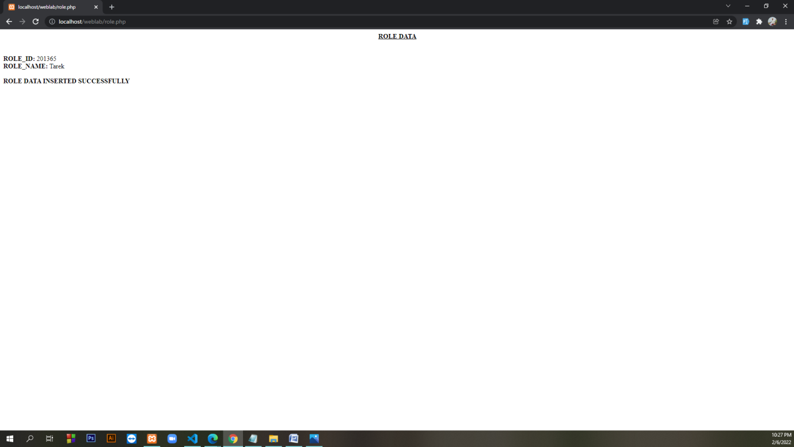

<?php

$con = mysqli_connect('localhost', 'root', '', 'rms');

if (isset($_POST['button'])) {

$roleid = $_POST['roleid'];

$rolename = $_POST['rolename'];

}

echo "<center><b><u> ROLE DATA</u> </b></center>";

echo "</br>";

echo "</br>";

echo "<b>ROLE_ID:</b> $roleid";

echo "</br>";

echo "<b>ROLE_NAME:</b> $rolename";

echo "</br>";

echo "</br>";

echo "<b>ROLE DATA INSERTED SUCCESSFULLY</b>";

$sql = "insert into role (role_id,role_name)values('$roleid','$rolename')";

mysqli_query($con, $sql);

**SALE**

**salesadmin.html**

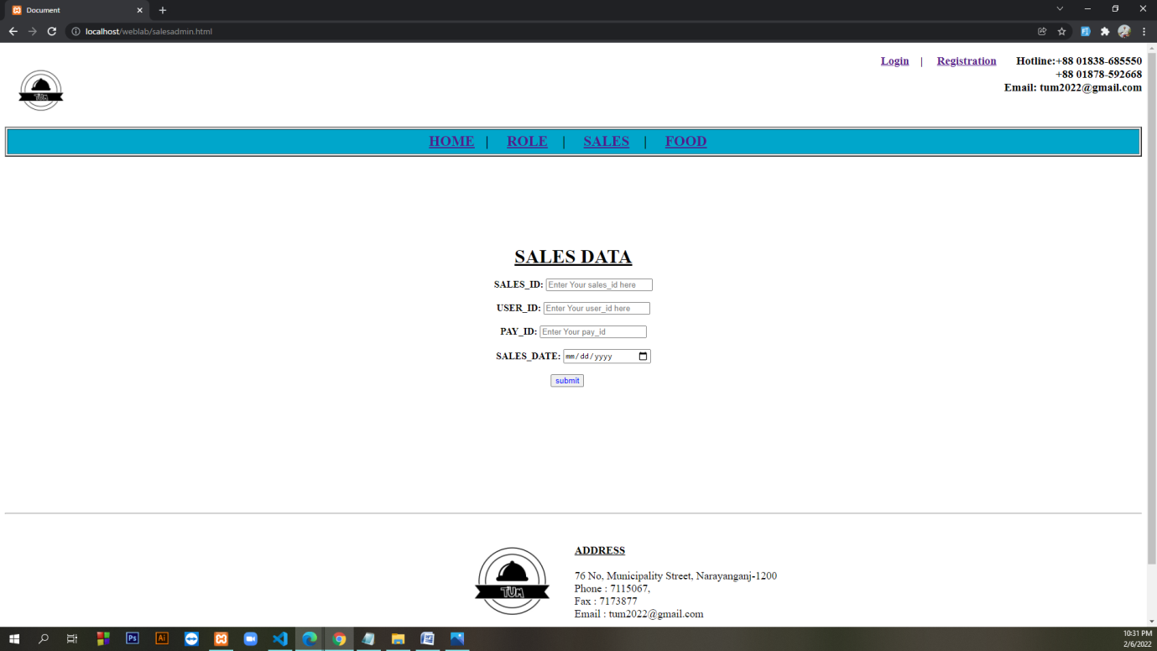

<!DOCTYPE html>

<html lang="en">

<head>

<meta charset="UTF-8">

<meta http-equiv="X-UA-Compatible" content="IE=edge">

<meta name="viewport" content="width=device-width, initial-scale=1.0">

<title>Document</title>

</head>

<body>

<a href="rms.html"><img align="left" height="120" width="120" src="logo.jpg"> </a>

<h3 align="right"><a href="login.html">Login</a> &nbsp&nbsp&nbsp| &nbsp&nbsp&nbsp <a

href="registration.html">Registration</a>

&nbsp&nbsp&nbsp&nbsp&nbsp&nbspHotline:+88 01838-685550 </br> +88 01878-592668 <br>

Email: tum2022@gmail.com </h3>

</br>

<table border="2" height="50" width="100%">

<tr height="100%" width="100%">

<td bgcolor=#00a6cb>

<center>

<font size="5">

<b>

<a href="rms.html">HOME</a>&nbsp&nbsp&nbsp| &nbsp&nbsp&nbsp

<a href="role.html">ROLE</a> &nbsp&nbsp&nbsp| &nbsp&nbsp&nbsp

<a href="salesadmin.html">SALES</a>&nbsp&nbsp&nbsp | &nbsp&nbsp&nbsp

<a href="foodsadmin.html">FOOD</a>&nbsp&nbsp&nbsp

</b>

</font>

</center>

</td>

</tr>

</table>

</br></br></br></br></br>

<table border="0" height="auto" width="100%">

<tr>

<td height="20%" width="50%" bgcolor="white">

<form action="salesadmin.php" method="POST">

<center>

</br></br></br>

<font size="6"><u><b>SALES DATA</b></u></font> </br></br>

<label><b>SALES_ID:</b></label>

<input type="text" placeholder="Enter Your sales_id here" name="salesid"> </br></br>

<label><b>USER_ID:</b></label>

<input type="text" placeholder="Enter Your user_id here" name="userid"> </br></br>

<label><b>PAY_ID:</b></label>

<input type="text" placeholder="Enter Your pay_id" name="payid"> </br></br>

<label><b>SALES_DATE:</b></label>

<input type="date" name="salesdate"> </br></br>

<input type="Submit" style="color:blue" value="submit" name="button">

&nbsp&nbsp&nbsp&nbsp</br></br>

</form>

</td>

</tr>

</table>

</br></br></br></br></br></br></br></br></br></br>

<hr>

<table border="0" height="10%" width="100%">

<tr>

<td height="20%" width="50%" bgcolor="white">

<DIV align="right"><a href="rms.html"><img height="200" width="200" src="logo.jpg"></a></DIV>

</td>

<td height="20%" width="50%" bgcolor="white">

<font size="4">

<DIV align="left">

</br> <b><u> ADDRESS</u></b> </br> </br>

</DIV>

76 No, Municipality Street, Narayanganj-1200</br>

Phone : 7115067, </br>

Fax : 7173877</br>

Email : tum2022@gmail.com</br></br>

</font>

</align>

</center>

</td>

</tr>

</table>

<hr>

<h3 align="center">All Rights &copy; TUM </h3>

</body>

</html>

**salesadmin.php**

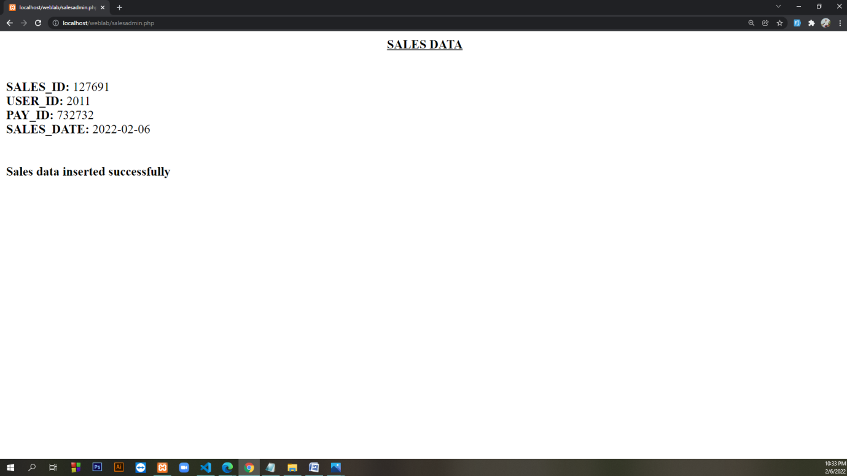

<?php

$con = mysqli_connect('localhost', 'root', '', 'rms');

if (isset($_POST['button'])) {

$salesid = $_POST['salesid'];

$userid = $_POST['userid'];

$payid = $_POST['payid'];

$salesdate = $_POST['salesdate'];

}

echo "<center><b><u> SALES DATA</u> </b></center>";

echo "</br>";

echo "</br>";

echo "<b>SALES_ID:</b> $salesid";

echo "</br>";

echo "<b>USER_ID:</b> $userid";

echo "</br>";

echo "<b>PAY_ID:</b> $payid";

echo "</br>";

echo "<b>SALES_DATE:</b> $salesdate";

echo "</br>";

echo "</br>";

echo "</br>";

echo "<b>Sales data inserted successfully</b>";

$sql = "insert into sales (sales_id,user_id,pay_id,sales_date)values('$salesid','$userid','$payid','$salesdate')";

mysqli_query($con, $sql);

**FOOD**

**foodsadmin.html**

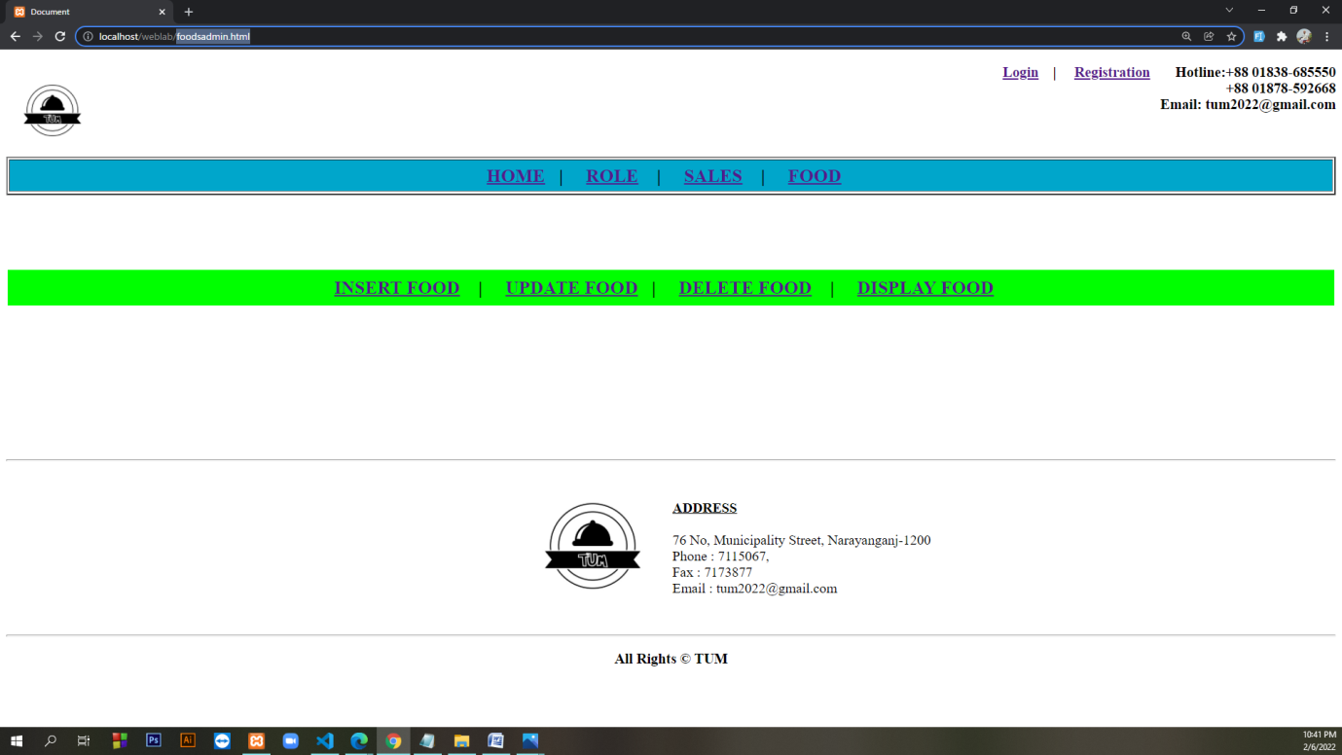

<!DOCTYPE html>

<html lang="en">

<head>

<meta charset="UTF-8">

<meta http-equiv="X-UA-Compatible" content="IE=edge">

<meta name="viewport" content="width=device-width, initial-scale=1.0">

<title>Document</title>

</head>

<body>

<a href="rms.html"><img align="left" height="120" width="120" src="logo.jpg"> </a>

<h3 align="right"><a href="login.html">Login</a> &nbsp&nbsp&nbsp| &nbsp&nbsp&nbsp <a

href="registration.html">Registration</a>

&nbsp&nbsp&nbsp&nbsp&nbsp&nbspHotline:+88 01838-685550 </br> +88 01878-592668 <br>

Email: tum2022@gmail.com </h3>

</br>

<table border="2" height="50" width="100%">

<tr height="100%" width="100%">

<td bgcolor=#00a6cb>

<center>

<font size="5">

<b>

<a href="rms.html">HOME</a>&nbsp&nbsp&nbsp| &nbsp&nbsp&nbsp

<a href="role.html">ROLE</a> &nbsp&nbsp&nbsp| &nbsp&nbsp&nbsp

<a href="salesadmin.html">SALES</a>&nbsp&nbsp&nbsp | &nbsp&nbsp&nbsp

<a href="foodsadmin.html">FOOD</a>&nbsp&nbsp&nbsp

</b>

</font>

</center>

</td>

</tr>

</table>

</br></br></br></br></br>

<table border="0" height="50" width="100%">

<tr height="100%" width="100%">

<td bgcolor="lime">

<center>

<font size="5">

<b>

<a href="insertfood.html">INSERT FOOD</a>&nbsp&nbsp&nbsp | &nbsp&nbsp&nbsp

<a href="update_food.php">UPDATE FOOD</a>&nbsp&nbsp&nbsp| &nbsp&nbsp&nbsp

<a href="delete_food.php">DELETE FOOD</a> &nbsp&nbsp&nbsp| &nbsp&nbsp&nbsp

<a href="display_food.php">DISPLAY FOOD</a>&nbsp&nbsp&nbsp

</b>

</font>

</center>

</td>

</tr>

</table>

</br></br></br></br></br></br></br></br></br></br>

<hr>

<table border="0" height="10%" width="100%">

<tr>

<td height="20%" width="50%" bgcolor="white">

<DIV align="right"><a href="rms.html"><img height="200" width="200" src="logo.jpg"></a></DIV>

</td>

<td height="20%" width="50%" bgcolor="white">

<font size="4">

<DIV align="left">

</br> <b><u> ADDRESS</u></b> </br> </br>

</DIV>

76 No, Municipality Street, Narayanganj-1200</br>

Phone : 7115067, </br>

Fax : 7173877</br>

Email : tum2022@gmail.com</br></br>

</font>

</align>

</center>

</td>

</tr>

</table>

<hr>

<h3 align="center">All Rights &copy; TUM </h3>

</body>

</html>

**insertfood.html**

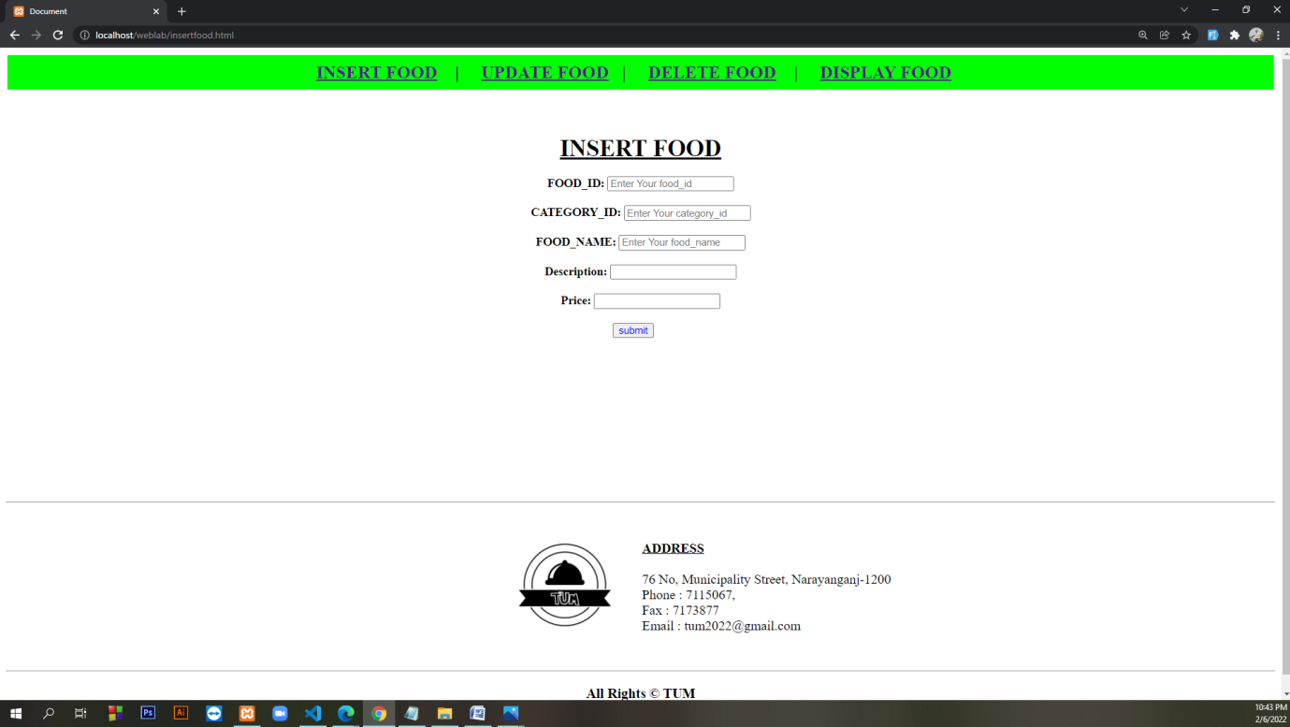

<!DOCTYPE html>

<html lang="en">

<head>

<meta charset="UTF-8">

<meta http-equiv="X-UA-Compatible" content="IE=edge">

<meta name="viewport" content="width=device-width, initial-scale=1.0">

<title>Document</title>

</head>

<body>

<table border="0" height="50" width="100%">

<tr height="100%" width="100%">

<td bgcolor="lime">

<center>

<font size="5">

<b>

<a href="insertfood.html">INSERT FOOD</a>&nbsp&nbsp&nbsp | &nbsp&nbsp&nbsp

<a href="update_food.php">UPDATE FOOD</a>&nbsp&nbsp&nbsp| &nbsp&nbsp&nbsp

<a href="delete_food.php">DELETE FOOD</a> &nbsp&nbsp&nbsp| &nbsp&nbsp&nbsp

<a href="display_food.php">DISPLAY FOOD</a>&nbsp&nbsp&nbsp

</b>

</font>

</center>

</td>

</tr>

</table>

<table border="0" height="auto" width="100%">

<tr>

<td height="20%" width="50%" bgcolor="white">

<form action="foodsadmin.php" method="POST">

<center>

</br></br></br>

<font size="6"><u><b>INSERT FOOD</b></u></font> </br></br>

<label><b>FOOD_ID:</b></label>

<input type="text" placeholder="Enter Your food_id" name="foodid"> </br></br>

<label><b>CATEGORY_ID:</b></label>

<input type="text" placeholder="Enter Your category_id" name="catid"> </br></br>

<label><b>FOOD_NAME:</b></label>

<input type="text" placeholder="Enter Your food_name" name="foodname"> </br></br>

<label><b>Description:</b></label>

<input type="text" name="des"> </br></br>

<label><b>Price:</b></label>

<input type="text" name="price"> </br></br>

<input type="Submit" style="color:blue" value="submit" name="button">

&nbsp&nbsp&nbsp&nbsp</br></br>

</form>

</td>

</tr>

</table>

</br></br></br></br></br></br></br></br></br></br>

<hr>

<table border="0" height="10%" width="100%">

<tr>

<td height="20%" width="50%" bgcolor="white">

<DIV align="right"><a href="rms.html"><img height="200" width="200" src="logo.jpg"></a></DIV>

</td>

<td height="20%" width="50%" bgcolor="white">

<font size="4">

<DIV align="left">

</br> <b><u> ADDRESS</u></b> </br> </br>

</DIV>

76 No, Municipality Street, Narayanganj-1200</br>

Phone : 7115067, </br>

Fax : 7173877</br>

Email : tum2022@gmail.com</br></br>

</font>

</align>

</center>

</td>

</tr>

</table>

<hr>

<h3 align="center">All Rights &copy; TUM </h3>

</body>

</html>

**foodsadmin.php**

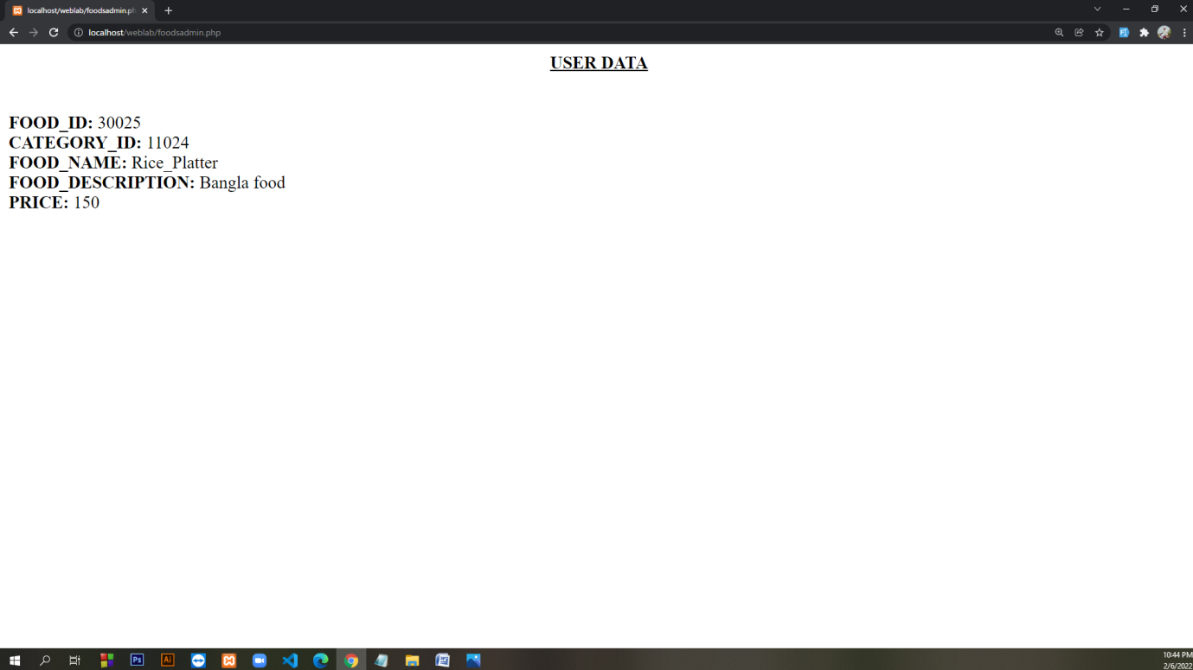

<?php

$con=mysqli_connect('localhost','root', '','rms');

if (isset ($_POST['button']))

{

$fid = $_POST ['foodid'];

$ctid = $_POST ['catid'];

$fname = $_POST ['foodname'];

$ds = $_POST ['des'];

$price = $_POST ['price'];

}

echo "<center><b><u> USER DATA</u> </b></center>";

echo "</br>";

echo "</br>";

echo "<b>FOOD_ID:</b> $fid";

echo "</br>";

echo "<b>CATEGORY_ID:</b> $ctid";

echo "</br>";

echo "<b>FOOD_NAME:</b> $fname";

echo "</br>";

echo "<b>FOOD_DESCRIPTION:</b> $ds";

echo "</br>";

echo "<b>PRICE:</b> $price";

echo "</br>";

$sql="insert into foods (food_id,category_id,food_name,food_description, price)values('$fid','$ctid','$fname','$ds','$price')";

mysqli_query($con,$sql);

?>

**delete_food.php**

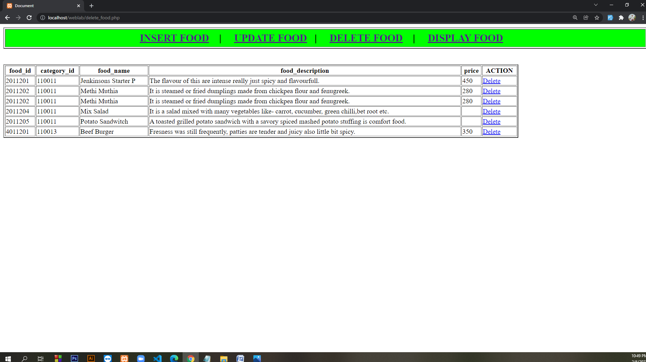

<!DOCTYPE html>

<html lang="en">

<head>

<meta charset="UTF-8">

<meta http-equiv="X-UA-Compatible" content="IE=edge">

<meta name="viewport" content="width=device-width, initial-scale=1.0">

<title>Document</title>

</head>

<body>

<table border="2" height="50" width="100%">

<tr height="100%" width="100%">

<td bgcolor="lime">

<center>

<font size="5">

<b>

<a href="insertfood.html">INSERT FOOD</a>&nbsp&nbsp&nbsp | &nbsp&nbsp&nbsp

<a href="update_food.php">UPDATE FOOD</a>&nbsp&nbsp&nbsp| &nbsp&nbsp&nbsp

<a href="delete_food.php">DELETE FOOD</a> &nbsp&nbsp&nbsp| &nbsp&nbsp&nbsp

<a href="display_food.php">DISPLAY FOOD</a>&nbsp&nbsp&nbsp

</b>

</font>

</center>

</td>

</tr>

</table> <br><br>

</body>

</html>

<?php

$con = mysqli_connect('localhost', 'root', '', 'rms');

$sql = "select * from foods";

$res = mysqli_query($con, $sql);

?>

<!DOCTYPE html>

<html lang="en">

<head>

<meta charset="UTF-8">

<meta http-equiv="X-UA-Compatible" content="IE=edge">

<meta name="viewport" content="width=device-width, initial-scale=1.0">

<title>Document</title>

</head>

<body>

<table border="2" width="80%" height="100%">

<tr>

<td> <b>

<center>food_id</center>

</b></td>

<td> <b>

<center>category_id</center>

</b></td>

<td> <b>

<center>food_name</center>

</b></td>

<td> <b>

<center>food_description</center>

</b></td>

<td> <b>

<center>price</center>

</b></td>

<td> <b>

<center>ACTION</center>

</b></td>

</tr>

<?php while ($row = mysqli_fetch_assoc($res)) { ?>

<tr>

<?php $id = $row["food_id"]; ?>

<td><?php echo $row['food_id'] ?></td>

<td><?php echo $row['category_id'] ?></td>

<td><?php echo $row['food_name'] ?></td>

<td><?php echo $row['food_description'] ?></td>

<td><?php echo $row['price'] ?></td>

<td> <a href="deletesavefood.php?id=<?php echo $id; ?>"> Delete </a> </td>

</tr>

<?php } ?>

</table>

</body>

</html>

**deletesavefood.php**

<?php

$db = mysqli_connect('localhost','root', '','rms');

$id = $_GET['id'];

$qry = "delete from foods where food_id = $id";

if (mysqli_query($db,$qry)) {

header('location: delete_food.php');

}

else {

echo mysqli_error($db);

}

?>

**display_food.php**

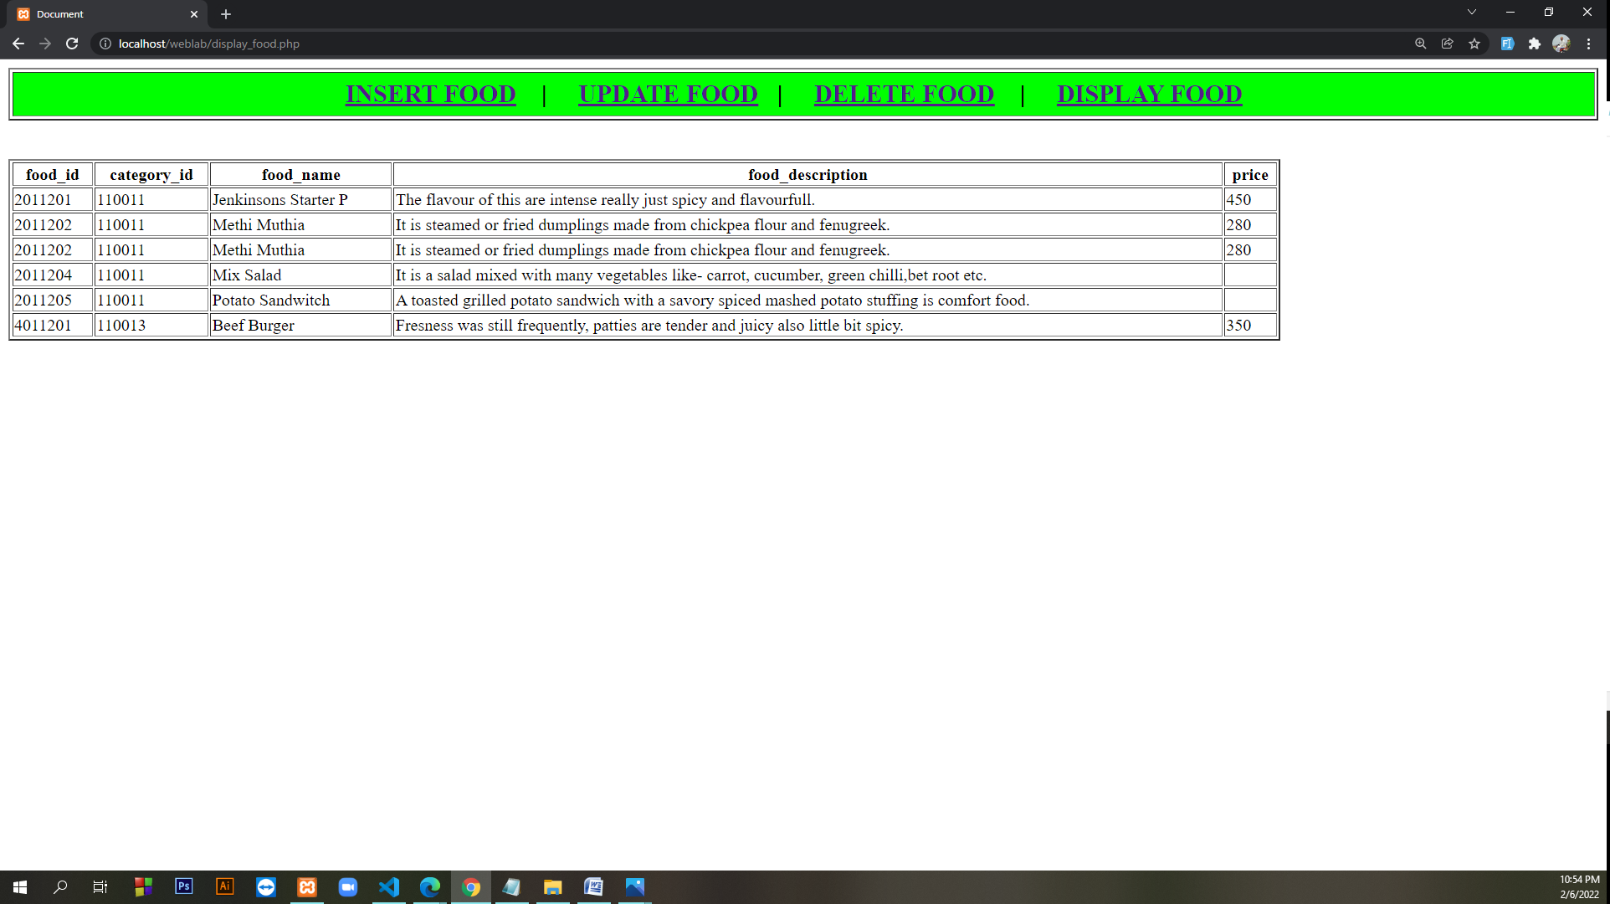

<!DOCTYPE html>

<html lang="en">

<head>

<meta charset="UTF-8">

<meta http-equiv="X-UA-Compatible" content="IE=edge">

<meta name="viewport" content="width=device-width, initial-scale=1.0">

<title>Document</title>

</head>

<body>

<table border="2" height="50" width="100%">

<tr height="100%" width="100%">

<td bgcolor="lime">

<center>

<font size="5">

<b>

<a href="insertfood.html">INSERT FOOD</a>&nbsp&nbsp&nbsp | &nbsp&nbsp&nbsp

<a href="update_food.php">UPDATE FOOD</a>&nbsp&nbsp&nbsp| &nbsp&nbsp&nbsp

<a href="delete_food.php">DELETE FOOD</a> &nbsp&nbsp&nbsp| &nbsp&nbsp&nbsp

<a href="display_food.php">DISPLAY FOOD</a>&nbsp&nbsp&nbsp

</b>

</font>

</center>

</td>

</tr>

</table><br><br>

</body>

</html>

<?php

$con = mysqli_connect('localhost', 'root', '', 'rms');

$sql = "select * from foods";

$res = mysqli_query($con, $sql);

?>

<!DOCTYPE html>

<html lang="en">

<head>

<meta charset="UTF-8">

<meta http-equiv="X-UA-Compatible" content="IE=edge">

<meta name="viewport" content="width=device-width, initial-scale=1.0">

<title>Document</title>

</head>

<body>

<table border="2" width="80%" height="100%">

<tr>

<td> <b>

<center>food_id</center>

</b></td>

<td> <b>

<center>category_id</center>

</b></td>

<td> <b>

<center>food_name</center>

</b></td>

<td> <b>

<center>food_description</center>

</b></td>

<td> <b>

<center>price</center>

</b></td>

</tr>

<?php while ($row = mysqli_fetch_assoc($res)) { ?>

<tr>

<td><?php echo $row['food_id'] ?></td>

<td><?php echo $row['category_id'] ?></td>

<td><?php echo $row['food_name'] ?></td>

<td><?php echo $row['food_description'] ?></td>

<td><?php echo $row['price'] ?></td>

</tr>

<?php } ?>

</table>

</body>

</html>